**Plants Medicine : Top 150 plants used as medicine**

Medicinal plants are useful to keep on hand to treat common ailments. You can reach for certain medical plants to relieve headaches, tummy trouble and even irritation from bug bites.

[Plants can be consumed in teas, used as a garnish, applied topically as an essential oil or consumed as a pill.](https://nurserylive.com/collections/medicinal-plants)

Note: It’s important to remember that you should always double-check with your doctor before consuming or using anything new for your body.

**How long have people been using plants medicine?**

Our earliest human ancestors found plants to heal wounds, cure diseases, and ease troubled minds.

Evidence exists that plants were used for medicinal purposes some 60,000 years ago. A burial site of a Neanderthal man was uncovered in 1960.

Eight species of plants had been buried with him, some of which are still used for medicinal purposes today.

If you choose to grow some of these plants, remember to take proper care according to the plant’s care guidelines and refrain from using any pesticides or other harmful chemicals on your plants.

[**Here is list of 150 plants as medicine:**](https://nurserylive.com/collections/medicinal-plants)

**1. Abscess root**

**Scientific name:** Polemonium reptans

It is used to reduce fever, inflammation, and cough.

[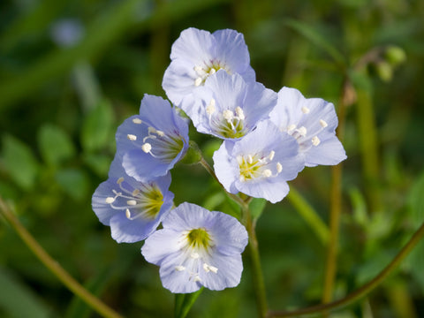](https://nurserylive.com/collections/medicinal-plants)

**2. Acai**

**Scientific name:** Euterpe oleracea

Although acai berries are a longstanding food source for indigenous people of the Amazon, there is no evidence that they have historically served a medicinal, as opposed to nutritional role.

In spite of their recent popularity in the United States as a dietary supplement, there is currently no evidence for their effectiveness for any health-related purpose.

[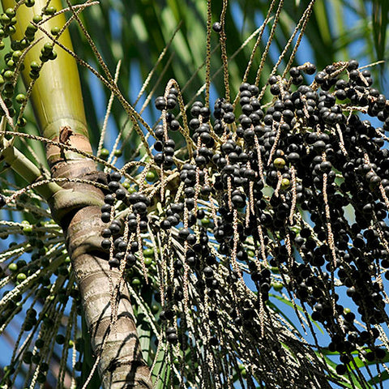](https://nurserylive.com/collections/medicinal-plants)

**3. Alder buckthorn**

**Scientific name:** Frangula alnus

Bark (and to a lesser extent the fruit) has been used as a laxative, due to its 3 – 7% anthraquinone content.

Bark for medicinal use is dried and stored for a year before use, as fresh bark is violently purgative; even dried bark can be dangerous if taken in excess.

[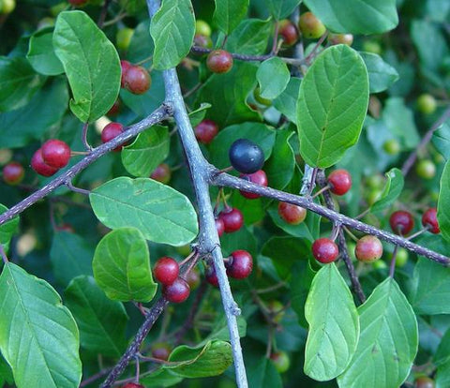](https://nurserylive.com/collections/medicinal-plants)

**4.**[**Alfalfa**](https://nurserylive.com/products/alfalfa-plant)

**Scientific name:** Medicago sativa

The leaves are used to lower cholesterol, as well as forum kidney and urinary tract ailments, although there is insufficient scientific evidence for its efficacy.

[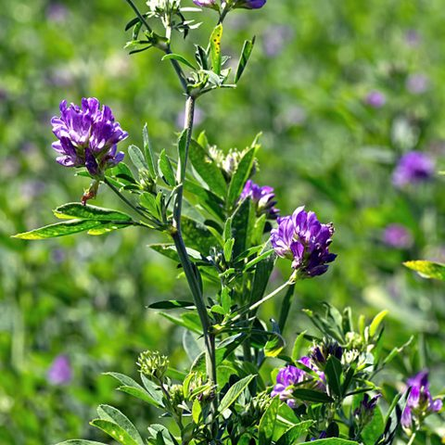](https://nurserylive.com/products/alfalfa-plant)

**5.**[**Aloe vera**](https://nurserylive.com/products/aloe-vera-plant)

**Scientific name:** [Aloe vera](https://nurserylive.com/products/aloe-vera-plant)

Leaves are widely used to heal burns, wounds and other skin ailments.

[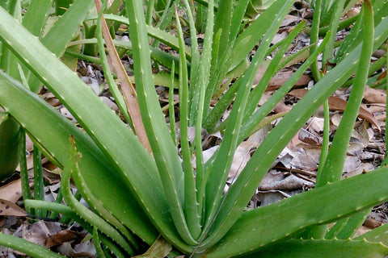](https://nurserylive.com/products/aloe-vera-plant)

**6. Amargo, bitter-wood**

**Scientific name:** Quassia amara

A 2012 study found a topical gel with 4% Quassia extract to be a safe and effective cure of rosacea.

[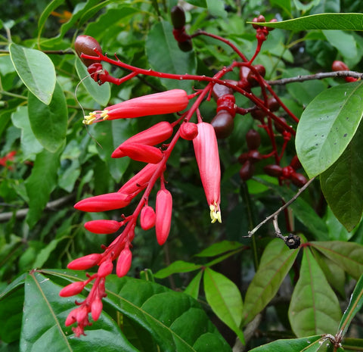](https://nurserylive.com/collections/medicinal-plants)

**7. Arnica**

**Scientific name:** Arnica montana

Used as an anti-inflammatory and for osteoarthritis. The US Food and Drug Administration has classified Arnica montana as an unsafe herb because of its toxicity. It should not be taken orally or applied to broken skin where absorption can occur.

[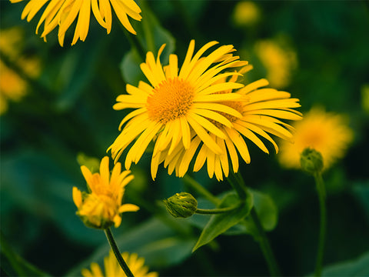](https://nurserylive.com/collections/medicinal-plants)

**8.**[**Asafoetida**](https://nurserylive.com/products/hing-asafoetida-plant)

**Scientific name:** Ferula assa-foetida

Might be useful for IBS, high cholesterol, and breathing problems.

[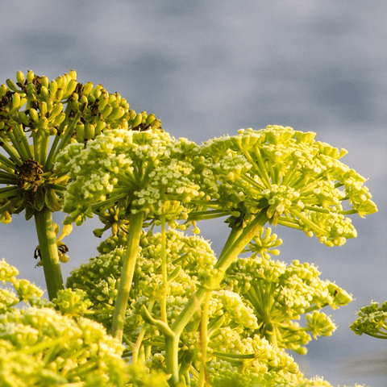](https://nurserylive.com/products/hing-asafoetida-plant)

**9. [Ashoka tree](https://nurserylive.com/products/ashoka-tree-pendula-ashok-plant" \o "Ashoka tree)**

**Scientific name:** Saraca indica

The plant is used in Ayurvedic traditions to treat gynecological disorders. The bark is also used to combat oedema or swelling.

[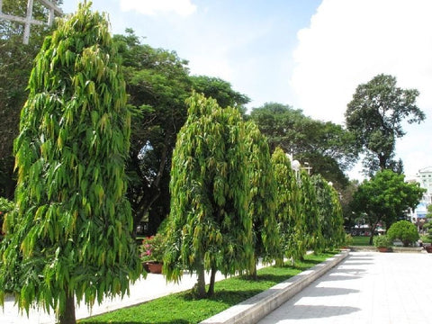](https://nurserylive.com/products/ashoka-tree-pendula-ashok-plant)

**10. [Ashwagandha](https://nurserylive.com/collections/all/products/ashwagandha-plant" \o "Ashwagandha)**

**Scientific name:** Withania somnifera

The plant's long, brown, tuberous roots are used in traditional medicine. In Ayurveda, the berries and leaves are applied externally to tumors, tubercular glands, carbuncles, and ulcers.

[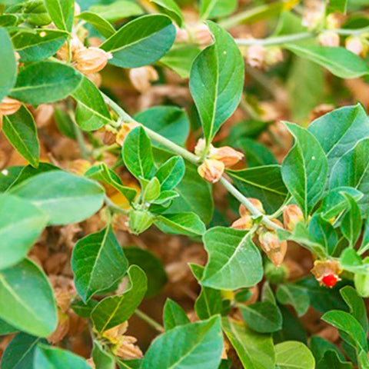](https://nurserylive.com/collections/all/products/ashwagandha-plant)

**11. Asthma-plant**

**Scientific name:** Euphorbia hirta

Used traditionally in Asia to treat bronchitic asthma and laryngeal spasm. It is used in the Philippines for dengue fever.

[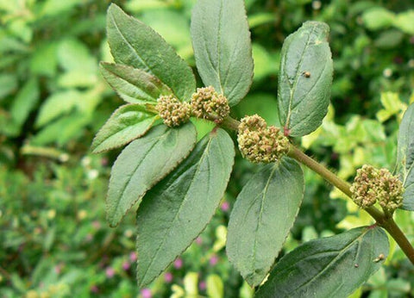](https://nurserylive.com/collections/medicinal-plants)

**12. Astragalus**

**Scientific name:** Astragalus propinquus

Long been used in traditional Chinese medicine to strengthen the immune system, and is used in modern China to treat hepatitis and as an adjunctive therapy in cancer.

[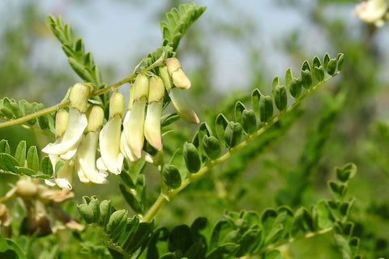](https://nurserylive.com/collections/medicinal-plants)

**13. Avaram senna**

**Scientific name:** Senna auriculata

The root is used in decoctions against fevers, diabetes, diseases of urinary system and constipation. The leaves have laxative properties.

The dried flowers and flower buds are used as a substitute for tea in case of diabetes patients. The powdered seed is also applied to the eye, in case of chronic purulent conjunctivitis.

[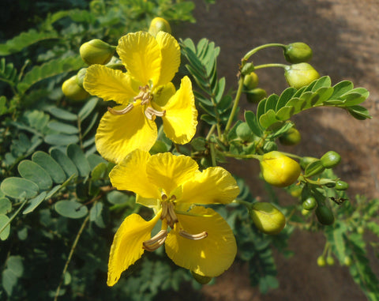](https://nurserylive.com/collections/medicinal-plants)

**14. Barberry**

**Scientific name:** Berberis vulgaris

Long history of medicinal use, dating back to the Middle Ages particularly among Native Americans. Uses have included skin ailments, scurvy and gastro-intestinal ailments.

[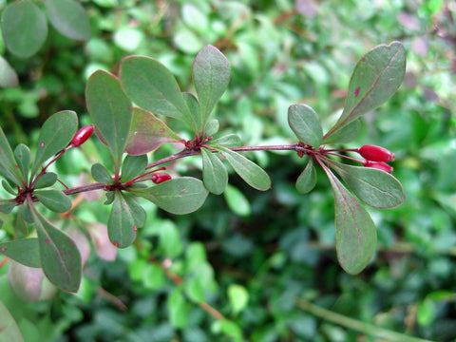](https://nurserylive.com/collections/medicinal-plants)

**15. Bay laurel**

**Scientific name:** Laurus nobilis

Aqueous extracts of bay laurel can be used as astringents and even as a reasonable salve for open wounds.

In massage therapy, the essential oil of bay laurel is reputed to alleviate arthritis and rheumatism, while in aromatherapy it is used to treat earaches and high blood pressure.

[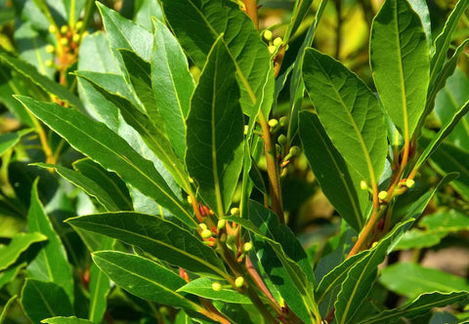](https://nurserylive.com/collections/medicinal-plants)

**16. Belladonna**

**Scientific name:** Atropa belladonna

Although toxic, was used historically in Italy by women to enlarge their pupils, as well as a sedative, among other uses. The name itself means "beautiful woman" in Italian.

[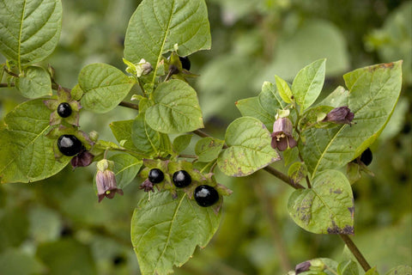](https://nurserylive.com/collections/medicinal-plants)

**17. Bilberry**

**Scientific name:** Vaccinium myrtillus

It is used to treat diarrhea, scurvy, and other conditions.

[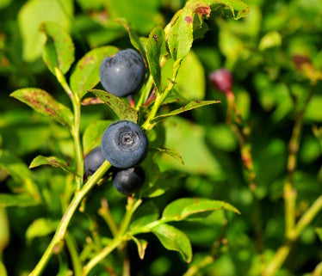](https://nurserylive.com/collections/medicinal-plants)

**18. Bitter leaf**

**Scientific name:** Vernonia amygdalina

The plant is used by both primates and indigenous peoples in Africa to treat intestinal ailments such as dysentery.

[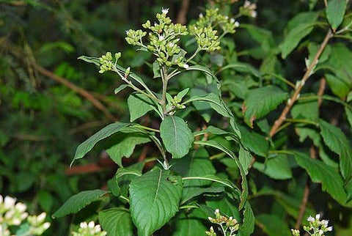](https://nurserylive.com/collections/medicinal-plants)

**19. Bitter melon**

**Scientific name:** Momordica charantia

The plant is used as an agent to reduce the blood glucose level.

[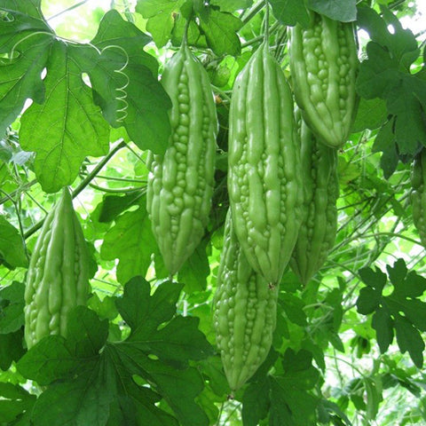](https://nurserylive.com/collections/medicinal-plants)

**20. Bitter orange**

**Scientific name:** Citrus × aurantium

Used in traditional Chinese medicine  and by indigenous peoples of the  Amazon for nausea, indigestion  and constipation.

[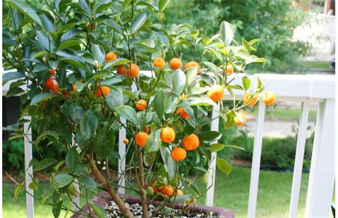](https://nurserylive.com/collections/medicinal-plants)

**21. Black cohosh**

**Scientific name:** Actaea racemosa

Historically used for arthritis and muscle pain, used more recently for conditions related to menopause and menstruation.

[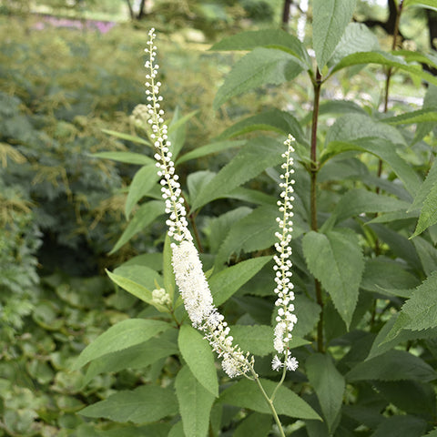](https://nurserylive.com/collections/medicinal-plants)

**22. Blessed thistle**

**Scientific name:** Cnicus benedictus

Used during the Middle Ages to treat bubonic plague. In modern times, herbal teas made from blessed thistle are used for loss of appetite, indigestion and other purposes.

[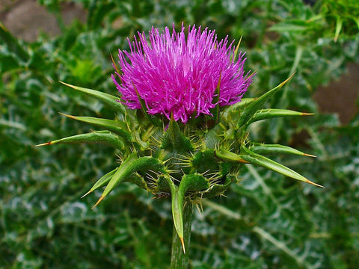](https://nurserylive.com/collections/medicinal-plants)

**23. Blue snakeweed**

**Scientific name:** Stachytarpheta cayennensis

Extracts of the plant are used to ease the symptoms of malaria. The boiled juice or a tea made from the leaves or the whole plant is taken to relieve fever and other symptoms. It is also used for dysentery, pain, and liver disorders.

A tea of the leaves is taken to help control diabetes in Peru and other areas. Laboratory tests indicate that the plant has anti-inflammatory properties.

[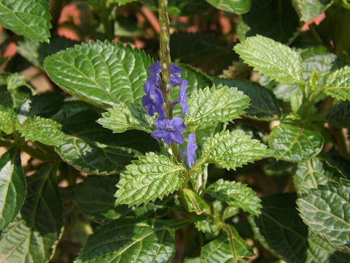](https://nurserylive.com/collections/medicinal-plants)

**24. Blueberries**

**Scientific name:** Vaccinium spec.

They are of current medical interest as an antioxidant and for urinary tract ailments.

[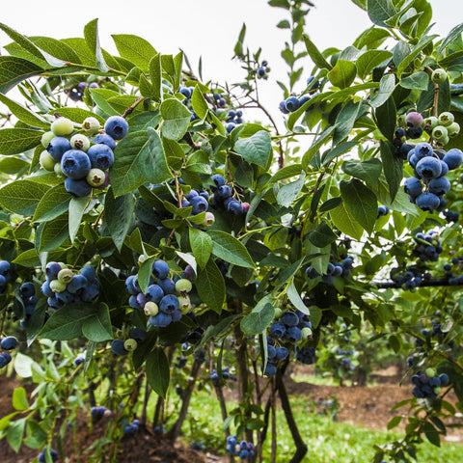](https://nurserylive.com/collections/medicinal-plants)

**25.**[**Borage**](https://nurserylive.com/products/borago-officinalis-plant)

**Scientific name:** Borago officinalis

Used in hyperactive gastrointestinal,  respiratory and cardiovascular disorders,  such as gastrointestinal (colic, cramps,  diarrhea), airways (asthma, bronchitis),  cardiovascular, (cardiotonic, antihypertensive  and blood purifier), urinary (diuretic  and kidney/ bladder disorders).

[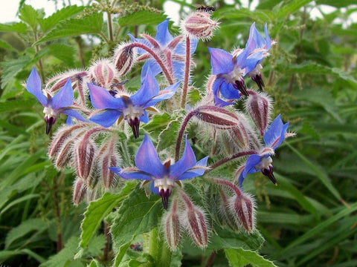](https://nurserylive.com/products/borago-officinalis-plant)

**26.**[**Burdock**](https://nurserylive.com/products/burdock-plant)

**Scientific name:** Arctium lappa

Used traditionally as a diuretic and to lower blood sugar and, in traditional Chinese medicine as a treatment for sore throat and symptoms of the common cold.

[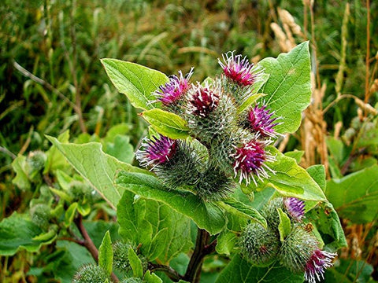](https://nurserylive.com/products/burdock-plant)

**27. Californian poppy**

**Scientific name:** Eschscholzia californica

Used as an herbal remedy: an aqueous extract of the plant has sedative and anxiolytic actions.

[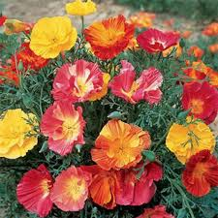](https://nurserylive.com/collections/medicinal-plants)

**28. Cannabis**

**Scientific name:** Cannabis

Used worldwide since ancient times as treatment for various conditions and ailments including pain, inflammation, gastrointestinal issues such as IBS, muscle relaxation, anxiety, Alzheimer's and dementia, ADHD, autism, cancer, cerebral palsy, recurring headaches, Crohn's disease, depression, epilepsy, glaucoma, insomnia, and neuropathy among others.

[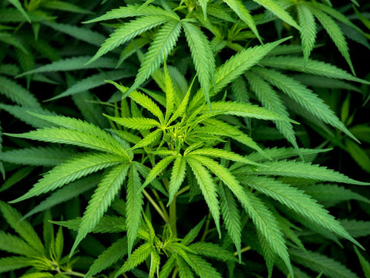](https://nurserylive.com/collections/medicinal-plants)

**29. Cat's claw**

**Scientific name:** Uncaria tomentosa

It has a long history of use in South America to prevent and treat disease.

[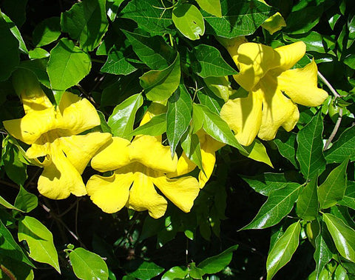](https://nurserylive.com/collections/medicinal-plants)

**30. Cayenne**

**Scientific name:** Capsicum annuum

Type of chili that has been used as both food and medicine for thousands of years. Uses have included reducing pain and swelling, lowering triglyceride and cholesterol levels and fighting viruses and harmful bacteria, due to high levels of Vitamin C.

[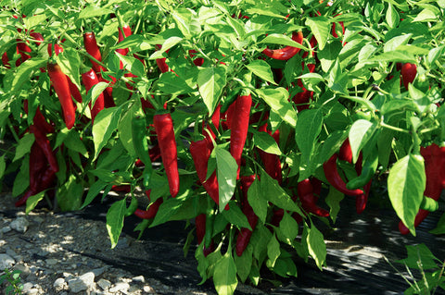](https://nurserylive.com/collections/seeds)

**31.**[**Celery**](https://nurserylive.com/products/omx-celery-imported-celery-tall-utah-seeds)

**Scientific name:** Apium graveolens

Seed is used only occasionally in tradition medicine. Modern usage is primarily as a diuretic.

[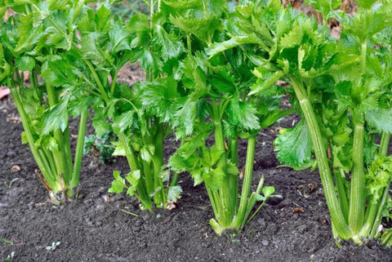](https://nurserylive.com/products/omx-celery-imported-celery-tall-utah-seeds)

**32.**[**Chamomile**](https://nurserylive.com/products/omx-german-chamomile-seeds)

**Scientific name:** Matricaria recutita and Anthemis nobilis

It has been used over thousands of years for a variety of conditions, including sleeplessness, anxiety, and gastrointestinal conditions such as upset stomach, gas, and diarrhea.

[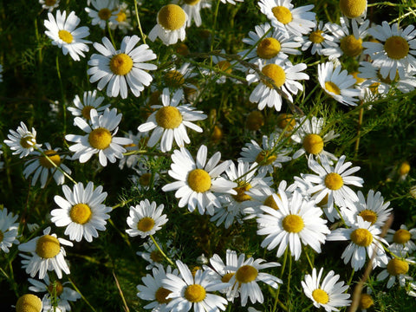](https://nurserylive.com/products/omx-german-chamomile-seeds)

**33. Chaparral**

**Scientific name:** Larrea tridentata

The leaves and twigs are used by Native Americans to make a herbal tea used for a variety of conditions, including arthritis, cancer and a number of others. Subsequent studies have been extremely variable, at best.

Chaparral has also been shown to have high liver toxicity, and has led to kidney failure, and is not recommended for any use by the U.S. Food and Drug Administration (FDA) or American Cancer Society.

[[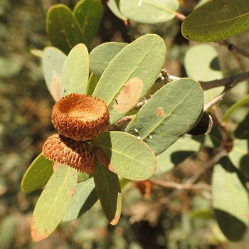](https://nurserylive.com/collections/medicinal-plants)](https://nurserylive.com/collections/medicinal-plants)

**34. Charcoal-tree**

**Scientific name:** Trema orientalis

The leaves and the bark are used to treat coughs, sore throats, asthma, bronchitis, gonorrhea, yellow fever, toothache, and as an antidote to general poisoning.

[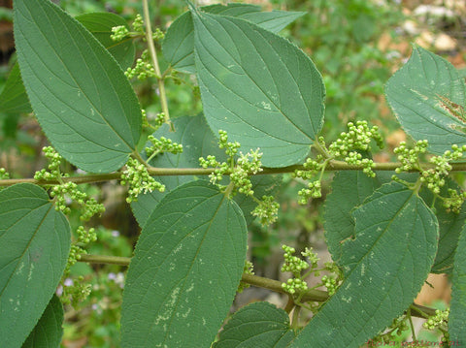](https://nurserylive.com/collections/seeds)

**35. Chasteberry**

**Scientific name:** Vitex agnus-castus

It has been used for over thousands of years for menstrual problems, and to stimulate lactation.

[[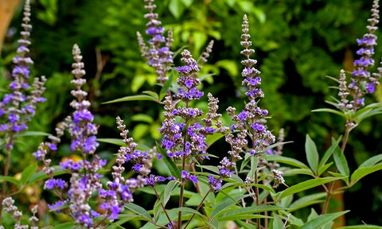](https://nurserylive.com/collections/medicinal-plants)](https://nurserylive.com/collections/medicinal-plants)

[**36. Chili**](https://nurserylive.com/collections/medicinal-plants)

**Scientific name:** Capsicum frutescens

Its active ingredient, capsaicine, is the basic of commercial pain-relief ointments in Western medicine. The low incidence of heart attack in Thais may be related to capsaicine's fibronolytic action (dissolving blood clots).

[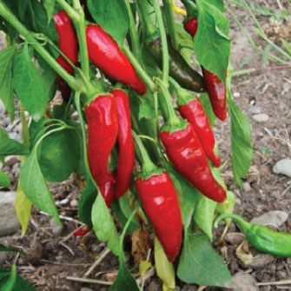](https://nurserylive.com/collections/all/products/chilli-jwala-seeds)

**37.**[**Cinchona**](https://nurserylive.com/products/cinchona-plant)

**Scientific name:** Cinchona spec.

Genus of about 38 species of trees whose bark is a source of alkaloids, including quinine. Its use as a febrifuge was first popularized in the 17th century by Peruvian Jesuits.

[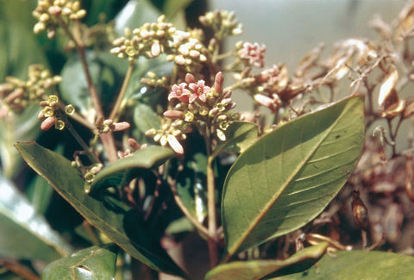](https://nurserylive.com/products/cinchona-plant)

**38. Cinnamon rose**

**Scientific name:** Rosa majalis

It yields edible hip fruits rich in vitamin C, which are used in medicine and to produce rose hip syrup.

[[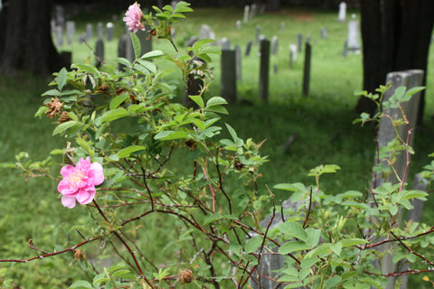](https://nurserylive.com/collections/medicinal-plants)](https://nurserylive.com/collections/medicinal-plants)

[**39. Clove**](https://nurserylive.com/collections/medicinal-plants)

**Scientific name:** Syzygium aromaticum

The plant is used for upset stomach and as an expectorant, among other purposes. The oil is used topically to treat toothache.

[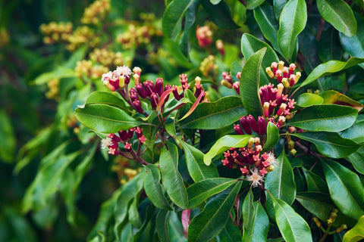](https://nurserylive.com/products/cloves-plant)

**40. Coffee senna**

**Scientific name:** Cassia occidentalis

Used in a wide variety of roles in traditional medicine, including in particular as a broad-spectrum internal and external antimicrobial, for liver disorders, for intestinal worms and other parasites and as an immune-system stimulant.

[[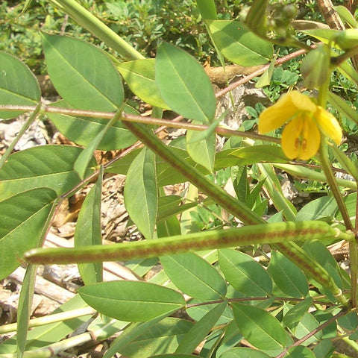](https://nurserylive.com/collections/medicinal-plants)](https://nurserylive.com/collections/medicinal-plants)

[**41. Comfrey**](https://nurserylive.com/collections/medicinal-plants)

**Scientific name:** Symphytum officinale

It has been used as a vulnerary and to reduce inflammation. It was also used internally in the past, for stomach and other ailments, but its toxicity has led a number of other countries, including Canada, Brazil, Australia, and the United Kingdom, to severely restrict or ban the use of comfrey.

[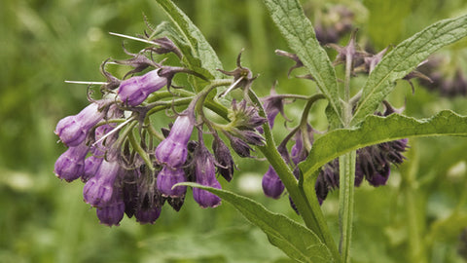](https://nurserylive.com/collections/all/products/comfrey-plant)

**42. Common chickweed**

**Scientific name:** Stellaria media

It has been used as a remedy  to treat itchy skin conditions and pulmonary diseases. 17th-century herbalist John  Gerard recommended it as a remedy for mange.  Modern herbalists prescribe  it for iron-deficiency anemia   (for its high iron content), as well as for skin  diseases, bronchitis,  rheumatic pains,  arthritis and period pain.

[[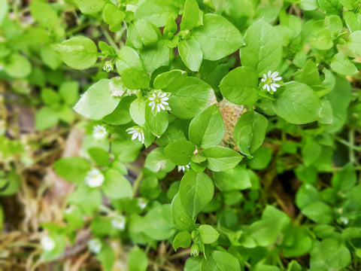](https://nurserylive.com/collections/medicinal-plants)](https://nurserylive.com/collections/medicinal-plants)

**43. Common hepatica**

**Scientific name:** Anemone hepatica

Historically used to treat liver diseases, it is still used in alternative medicine today. Other modern applications by herbalists include treatments for pimples, bronchitis and gout.

[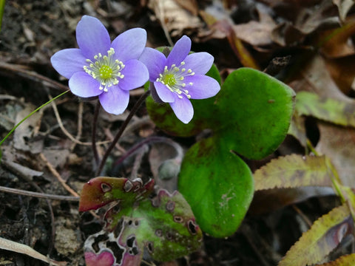](https://nurserylive.com/collections/seeds)

**44. Common hollyhock**

**Scientific name:** Alcea rosea

Believed to be an emollient and laxative. It is used to control inflammation, to stop bedwetting and as a mouthwash in cases of bleeding gums.

[[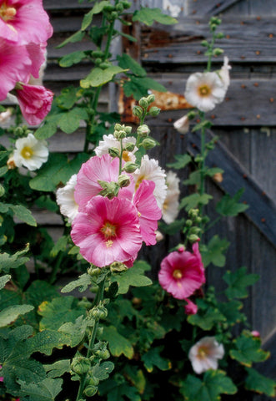](https://nurserylive.com/collections/medicinal-plants)](https://nurserylive.com/collections/medicinal-plants)

**45. Common mullein**

**Scientific name:** Verbascum thapsus

It contains glycyrrhizin compounds with bactericide and potential anti-tumoral action. These compounds are concentrated in the flowers.

[[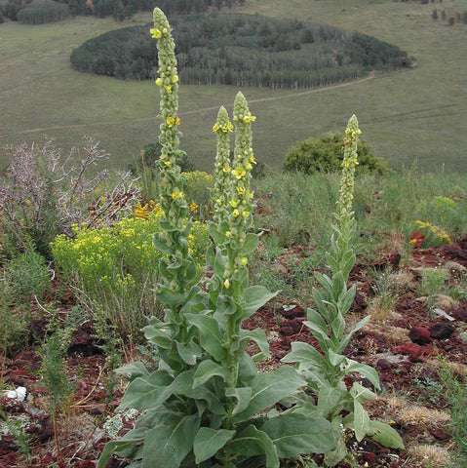](https://nurserylive.com/collections/medicinal-plants)](https://nurserylive.com/collections/medicinal-plants)

**46. Common nettle, stinging nettle**

**Scientific name:** Urtica dioica

It has been used in the traditional Austrian medicine internally (as tea or fresh leaves) to treat disorders of the kidneys and urinary tract, gastrointestinal tract, locomotor system, skin, cardiovascular system, hemorrhage, influenza, rheumatism, and gout.

[[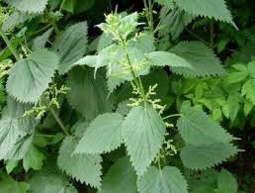](https://nurserylive.com/collections/medicinal-plants)](https://nurserylive.com/collections/medicinal-plants)

**47. Common witch-hazel**

**Scientific name:** Hamamelis virginiana

It produces a specific kind of tannins called hamamelitannins. One of those substances displays a specific cytotoxic activity against colon cancer cells.

[[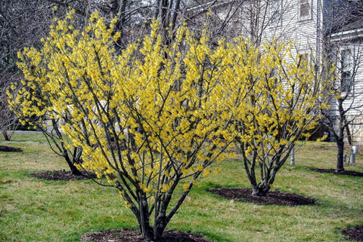](https://nurserylive.com/collections/medicinal-plants)](https://nurserylive.com/collections/medicinal-plants)

**48. Common yarrow**

**Scientific name:** Achillea millefolium

Purported to be a diaphoretic, astringent, tonic, stimulant and mild aromatic.

[[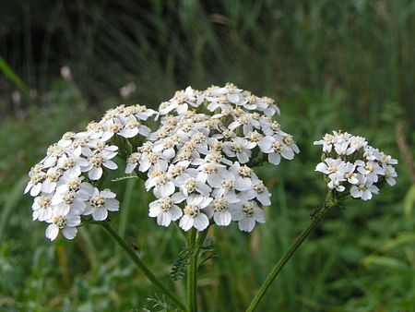](https://nurserylive.com/collections/medicinal-plants)](https://nurserylive.com/collections/medicinal-plants)

**49. Cornflower**

**Scientific name:** Centaurea cyanus

In herbalism, a decoction of cornflower is effective in treating conjunctivitis and as a wash for tired eyes.

[[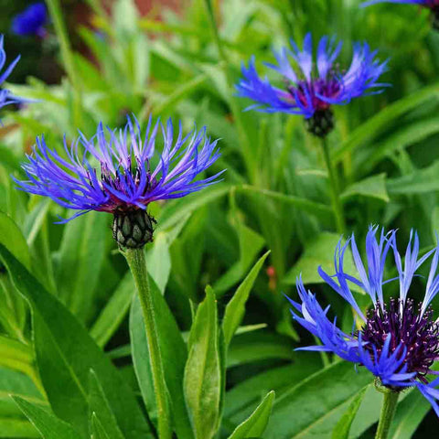](https://nurserylive.com/collections/medicinal-plants)](https://nurserylive.com/collections/medicinal-plants)

**50. Cotton lavender**

**Scientific name:** Santolina chamaecyparissus

Most commonly, the flowers and leaves are made into a decoction used to expel intestinal parasites.

[[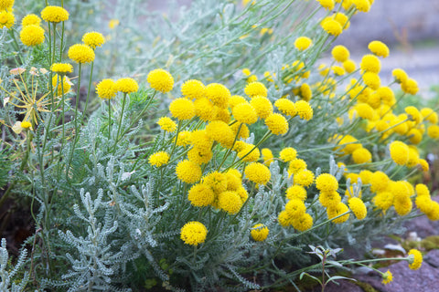](https://nurserylive.com/collections/medicinal-plants)](https://nurserylive.com/collections/medicinal-plants)

**51. Cranberry**

**Scientific name:** Vaccinium macrocarpon

It was used historically as a vulnerary and for urinary disorders, diarrhea, diabetes, stomach ailments, and liver problems. Modern usage has concentrated on urinary tract related problems.

[[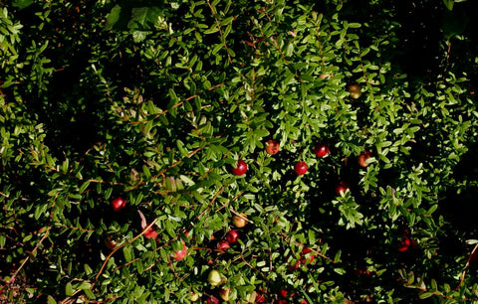](https://nurserylive.com/collections/medicinal-plants)](https://nurserylive.com/collections/medicinal-plants)

**52. Curly dock or yellow dock**

**Scientific name:** Rumex crispus

In Western herbalism the root is often used for treating anemia, due to its high level of iron. The plant will help with skin conditions if taken internally or applied externally to things like itching, scrofula, and sores. It is also used for respiratory conditions, specifically those with a tickling cough that is worse when exposed to cold air. It mentions also passing pains, excessive itching, and that it helps enlarged lymphs.

[[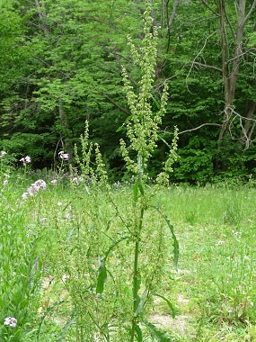](https://nurserylive.com/collections/medicinal-plants)](https://nurserylive.com/collections/medicinal-plants)

**53.**[**Daisy**](https://nurserylive.com/collections/all/products/rudbeckia-seeds)

**Scientific name:** Bellis perennis

Flowers have been used in the traditional Austrian medicine internally as tea (or the leaves as a salad) for treatment of disorders of the gastrointestinal and respiratory tract.

[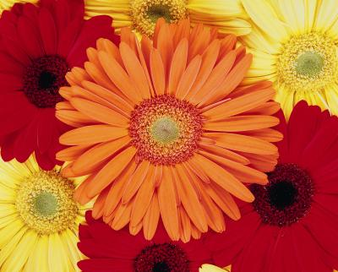](https://nurserylive.com/collections/all/products/omx-bellis-perensis-daisy-mixed-seeds)

**54.**[**Dandelion**](https://nurserylive.com/collections/all/products/dandelion-plant)

**Scientific name:** Taraxacum officinale

It was most commonly used historically to treat liver diseases, kidney diseases, and spleen problems.

[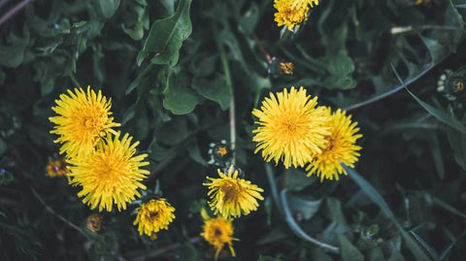](https://nurserylive.com/collections/all/products/dandelion-plant)

**55. Digitalis or foxglove**

**Scientific name:** Digitalis lanata

It came into use in treating cardiac disease in late 18th century England in spite of its high toxicity.a Its use has been almost entirely replaced by the pharmaceutical derivative Digoxin, which has a shorter half-life in the body, and whose toxicity is therefore more easily managed. Digoxin is used as an antiarrhythmic agent and inotrope.

[[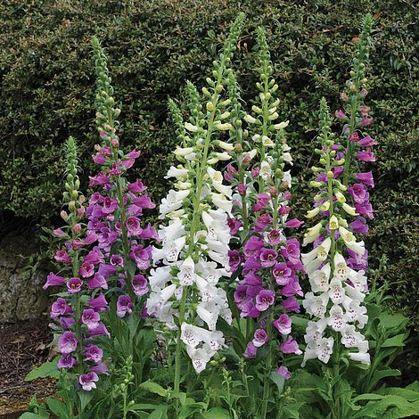](https://nurserylive.com/collections/medicinal-plants)](https://nurserylive.com/collections/medicinal-plants)

**56. Dong quai**

**Scientific name:** Angelica sinensis

Used for thousands of years in Asia, primarily in women's health.

[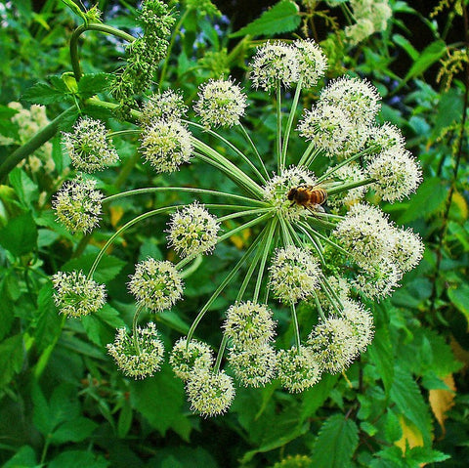](https://nurserylive.com/collections/medicinal-plants)

**57.**[**Drumstick tree**](https://nurserylive.com/collections/all/products/drumsticks-moringa-oleifera-plant)

**Scientific name:** Moringa oleifera

It is used for food and traditional medicine. It is undergoing preliminary research to investigate potential properties of its nutrients and phytochemicals

[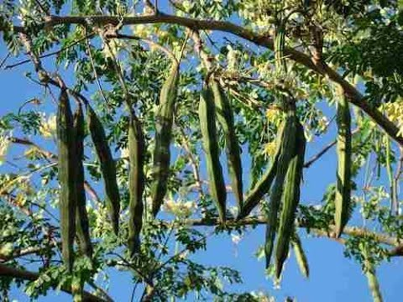](https://nurserylive.com/collections/all/products/drumsticks-moringa-oleifera-plant)

**58. Elderberry**

**Scientific name:** Sambucus nigra

The berries and leaves have traditionally been used to treat pain, swelling, infections, coughs, and skin conditions and, more recently, flu, common cold, fevers, constipation, and sinus infections.

[[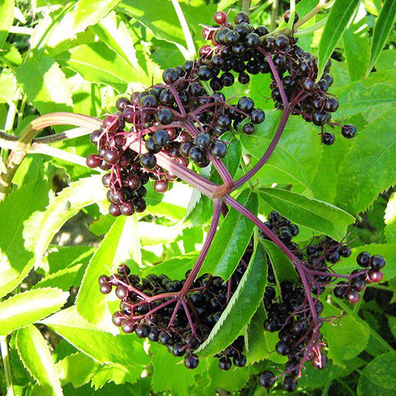](https://nurserylive.com/collections/medicinal-plants)](https://nurserylive.com/collections/medicinal-plants)

**59. Elecampane**

**Scientific name:** Inula helenium

It is used in herbal medicine as an expectorant and for water retention.

[[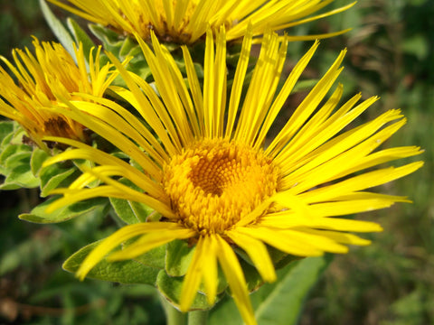](https://nurserylive.com/collections/medicinal-plants)](https://nurserylive.com/collections/medicinal-plants)

**60.**[**Eucalyptus**](https://nurserylive.com/collections/all/products/eucalyptus-tree-nilgiri-tree-plant)

**Scientific name:** Eucalyptus globulus

Leaves were widely used in traditional medicine as a febrifuge. Eucalyptus oil is commonly used in over-the-counter cough and cold medications, as well as for an analgesic.

[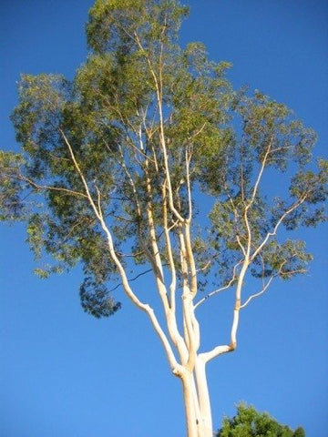](https://nurserylive.com/collections/all/products/eucalyptus-tree-nilgiri-tree-plant)

**61. European mistletoe**

**Scientific name:** Viscum album

It has been used to treat seizures, headaches, and other conditions.

[[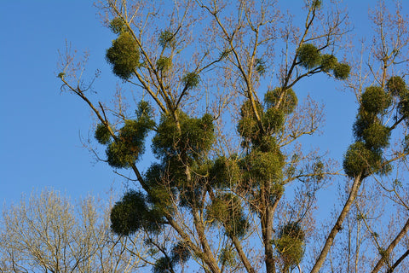](https://nurserylive.com/collections/medicinal-plants)](https://nurserylive.com/collections/medicinal-plants)

**62.**[**Evening primrose**](https://nurserylive.com/products/evening-primrose-plant)

**Scientific name:** Oenothera

Its oil has been used since the 1930s for eczema, and more recently as an anti-inflammatory.

[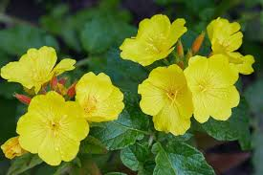](https://nurserylive.com/products/evening-primrose-plant)

**63. False sowthistle**

**Scientific name:** Reichardia tingitana

Uses in folk medicine have been recorded in the Middle East, its leaves being used to treat ailments such as constipation, colic and inflamed eyes.

[[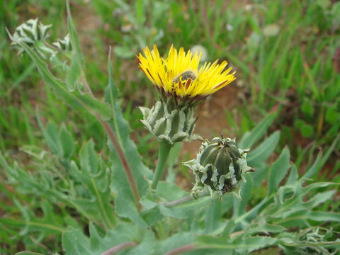](https://nurserylive.com/collections/medicinal-plants)](https://nurserylive.com/collections/medicinal-plants)

**64.**[**Fenugreek**](https://nurserylive.com/products/omx-methi-kasturi-fenugreek-seeds)

**Scientific name:** Trigonella foenum-graecum

It has long been used to treat symptoms of menopause, and digestive ailments. More recently, it has been used to treat diabetes, loss of appetite and other conditions

[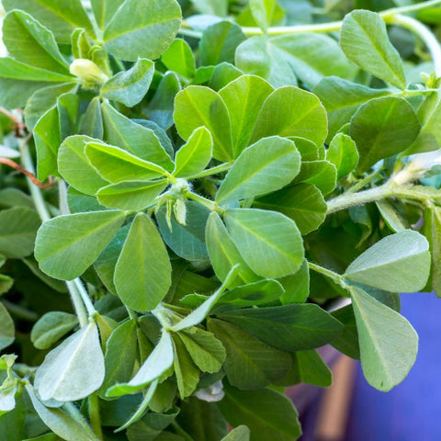](https://nurserylive.com/products/omx-methi-kasturi-fenugreek-seeds)

**65.**[**Feverfew**](https://nurserylive.com/products/feverfew-plant)

**Scientific name:** Tanacetum parthenium

The plant has been used for centuries for fevers, headaches, stomach aches, toothaches, insect bites and other conditions.

[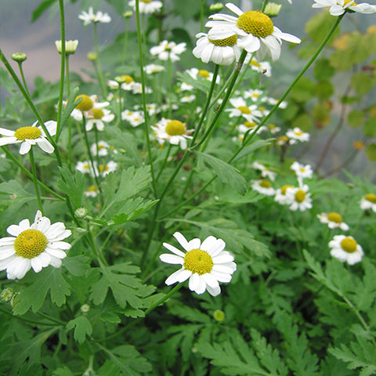](https://nurserylive.com/products/feverfew-plant)

**66. Field scabious**

**Scientific name:** Knautia arvensis

The whole plant is astringent and mildly diuretic. An infusion is used internally as a blood purifier and externally for treating cuts, burns and bruises.

[[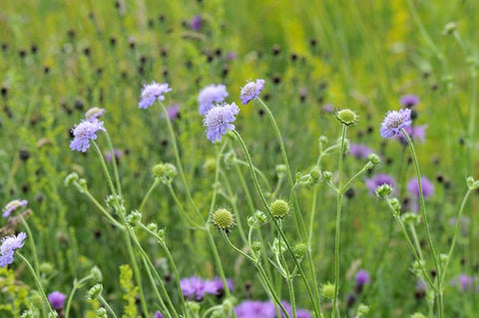](https://nurserylive.com/collections/medicinal-plants)](https://nurserylive.com/collections/medicinal-plants)

**67. Flaxseed**

**Scientific name:** Linum usitatissimum

The plant is most commonly used as a laxative. Flaxseed oil is used for different conditions, including arthritis.

[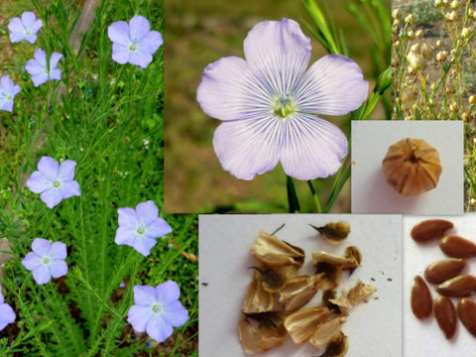](https://nurserylive.com/collections/medicinal-plants)

**68. Fumitory**

**Scientific name:** Fumaria officinalis

Traditionally thought to be good for the eyes and to remove skin blemishes. In modern times herbalists use it to treat skin diseases and conjunctivitis, as well as to cleanse the kidneys. However, Howard (1987) warns that fumitory is poisonous and should only be used under the direction of a medical herbalist.

[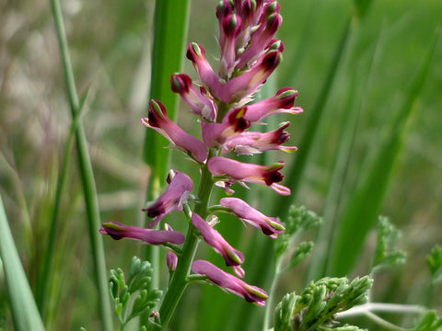](https://nurserylive.com/collections/medicinal-plants)

**69. Garden angelica**

**Scientific name:** Angelica archangelica

Roots have been used in the traditional Austrian medicine internally as tea or tincture for treatment of disorders of the gastrointestinal tract, respiratory tract, nervous system, and also against fever, infections, and flu.

[[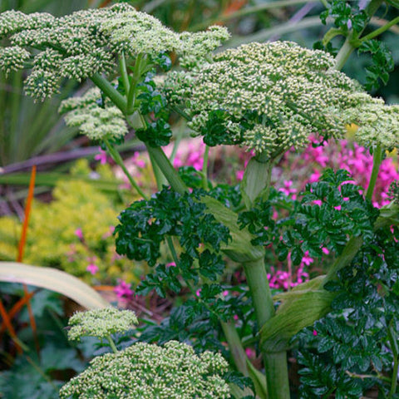](https://nurserylive.com/collections/medicinal-plants)](https://nurserylive.com/collections/medicinal-plants)

**70.**[**Garlic**](https://nurserylive.com/collections/all/products/omx-garlic-chives-seeds)

**Scientific name:** Allium sativum

Widely used as an antibiotic and, more recently, for treating cardiovascular disease Garlic is a monoamine oxidase inhibitor and has antidepressant-like effects on mice so might be used as a herbal antidepressant or anxiolytic in humans.

[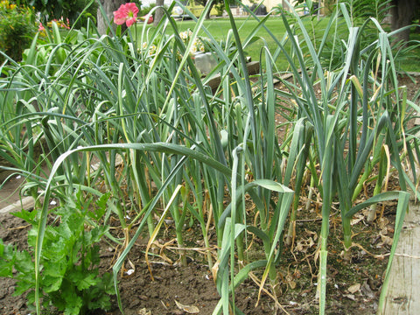](https://nurserylive.com/collections/all/products/omx-garlic-chives-seeds)

**71.**[**Ginger**](https://nurserylive.com/collections/all/products/greater-galangal-blue-ginger-thai-ginger-plant)

**Scientific name:** Zingiber officinale

The plant is used to relieve nausea.

[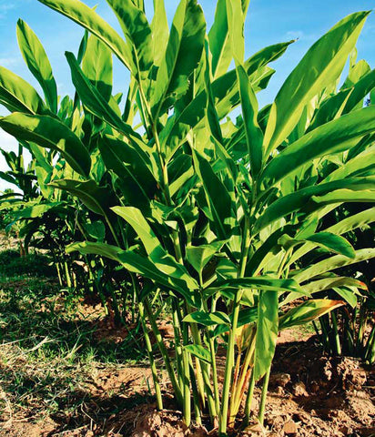](https://nurserylive.com/collections/all/products/greater-galangal-blue-ginger-thai-ginger-plant)

**72.**[**Ginkgo**](https://nurserylive.com/collections/all/products/ginkgo-biloba-plant)

**Scientific name:** Ginkgo biloba

The leaf extract has been used to treat asthma,  bronchitis, fatigue,  Alzheimer's and tinnitus.

[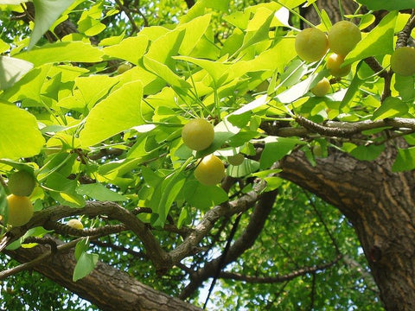](https://nurserylive.com/collections/all/products/ginkgo-biloba-plant)

**73.**[**Ginseng**](https://nurserylive.com/collections/all/products/ginseng-american-plant)

**Scientific name:** Panax spec.

Used medicinally, in particular in Asia, for over 2,000 years, and is widely used in modern society.

[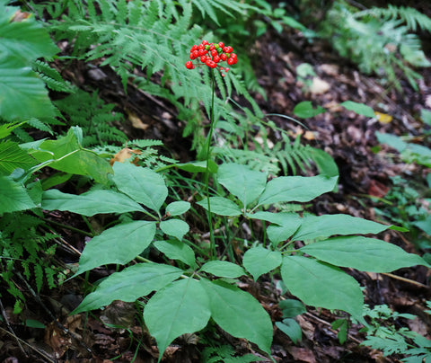](https://nurserylive.com/collections/all/products/ginseng-american-plant)

**74. Goldenseal**

**Scientific name:** Hydrastis canadensis

It was used traditionally by Native Americans to treat skin diseases, ulcers, and gonorrhea. More recently, the herb has been used to treat the respiratory tract and a number of other infections.

[[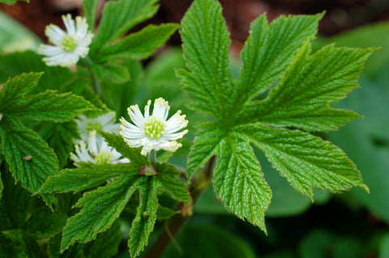](https://nurserylive.com/collections/medicinal-plants)](https://nurserylive.com/collections/medicinal-plants)

**75.**[**Grape**](https://nurserylive.com/collections/all/products/grape-angoor-plant-seedless-plant)

**Scientific name:** Vitis vinifera

The leaves and fruit have been used medicinally since the ancient Greeks.

[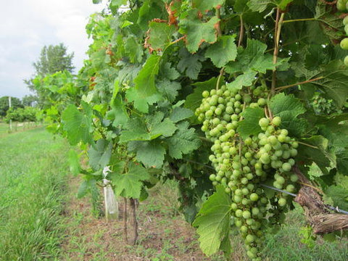](https://nurserylive.com/collections/all/products/grape-angoor-plant-seedless-plant)

**76. Ground-ivy**

**Scientific name:** Glechoma hederacea

It has been used as a "lung herb". Other traditional uses include as an expectorant, astringent, and to treat bronchitis. The essential oil of the plant has been used for centuries as a general tonic for colds and coughs, and to relieve congestion of the mucous membranes.

[[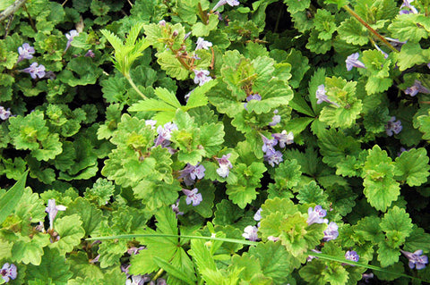](https://nurserylive.com/collections/medicinal-plants)](https://nurserylive.com/collections/medicinal-plants)

**77.**[**Guava**](https://nurserylive.com/collections/all/products/red-guava-amrud-psidium-guajava-plant)

**Scientific name:** Psidium guajava

It has a rich history of use in traditional medicine. It is traditionally used to treat diarrhea; however, evidence of its effectiveness is very limited.

[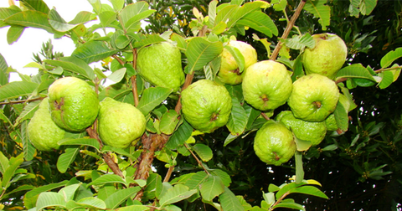](https://nurserylive.com/collections/all/products/red-guava-amrud-psidium-guajava-plant)

**78. Gum arabic**

**Scientific name:** Acacia senegal

A natural gum sourced from hardened sap of various species of acacia tree used as a binder and emulsifier.

[[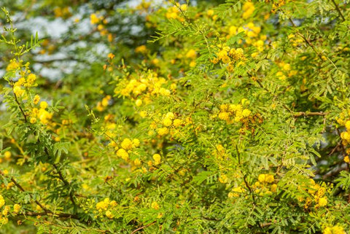](https://nurserylive.com/collections/medicinal-plants)](https://nurserylive.com/collections/medicinal-plants)

**79. Hawthorn**

**Scientific name:** Crataegus monogyna and Crataegus laevigata

Fruit has been used for centuries for heart disease. Other uses include digestive and kidney related problems.

[[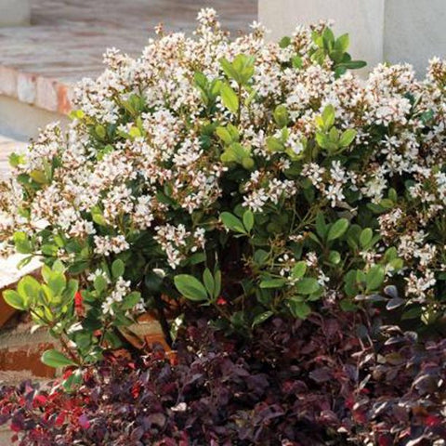](https://nurserylive.com/collections/medicinal-plants)](https://nurserylive.com/collections/medicinal-plants)

**80. Henna**

**Scientific name:** Lawsonia inermis

The plants exhibits potential antibacterial activity. The alcoholic extract of the root has antibacterial activity due to the presence of flavonoid and alkaloids. Henna is also thought to show anti-inflammatory, antipyretic, and analgesic effects in experimental animals.

[[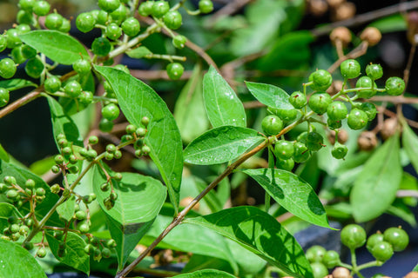](https://nurserylive.com/collections/medicinal-plants)](https://nurserylive.com/collections/medicinal-plants)

**81. Hoodia**

**Scientific name:** Hoodia gordonii

The plant is traditionally used by Kalahari San (Bushmen) to reduce hunger and thirst. It is currently marketed as an appetite suppressant.

[[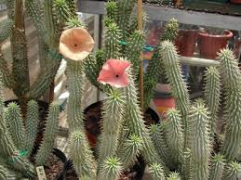](https://nurserylive.com/collections/medicinal-plants)](https://nurserylive.com/collections/medicinal-plants)

**82. Horse chestnut**

**Scientific name:** Aesculus hippocastanum

Its seeds, leaves, bark, and flowers have been used medicinally for many centuries. The raw plant materials are toxic unless processed.

[[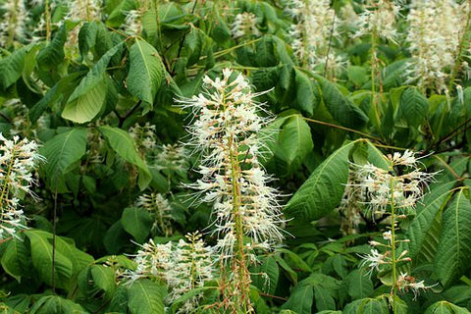](https://nurserylive.com/collections/medicinal-plants)](https://nurserylive.com/collections/medicinal-plants)

**83. Horsetail**

**Scientific name:** Equisetum arvense

Dates back to ancient Roman and Greek medicine, when it was used to stop bleeding, heal ulcers and wounds, and treat tuberculosis and kidney problems.

[[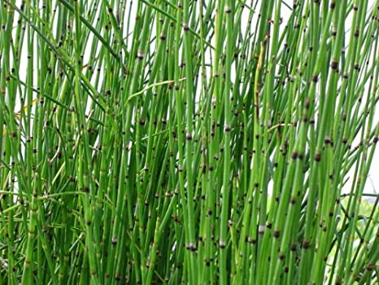](https://nurserylive.com/collections/medicinal-plants)](https://nurserylive.com/collections/medicinal-plants)

**84. Hyssop**

**Scientific name:** Hyssopus officinalis

It is used for digestive and intestinal problems including liver and gallbladder conditions, intestinal pain, intestinal gas, colic, and loss of appetite. It is also used for respiratory problems including coughs, the common cold, respiratory infections, sore throat, and asthma.

[[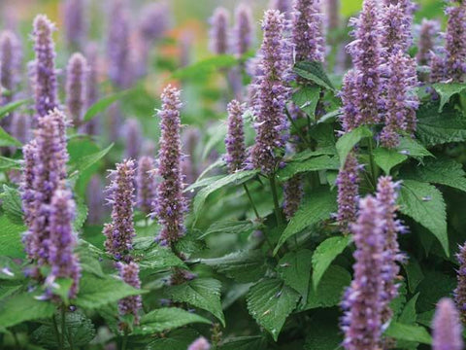](https://nurserylive.com/collections/medicinal-plants)](https://nurserylive.com/collections/medicinal-plants)

**85. Inchplant**

**Scientific name:** Tradescantia zebrina

It is used in southeast Mexico in the region of Tabasco as a cold herbal tea, which is named Matali. Skin irritation may result from repeated contact with or prolonged handling of the plant, particularly from the clear, watery sap (a characteristic unique to T. zebrina as compared with other types).

[[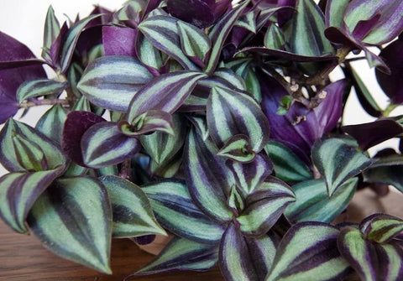](https://nurserylive.com/collections/medicinal-plants)](https://nurserylive.com/collections/medicinal-plants)

**86.**[**Indian sandalwood**](https://nurserylive.com/collections/all/products/white-sandalwood-tree-chandan-tree-plant)

**Scientific name:** Santalum album

Sandalwood oil has been widely used in folk medicine for treatment of common colds, bronchitis, skin disorders, heart ailments, general weakness, fever, infection of the urinary tract, inflammation of the mouth and pharynx, liver and gallbladder complaints and other maladies.

[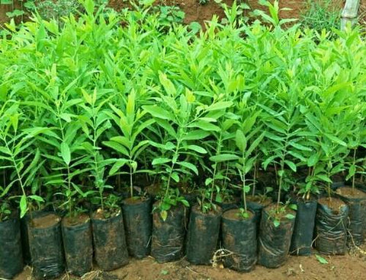](https://nurserylive.com/collections/all/products/white-sandalwood-tree-chandan-tree-plant)

**87. Jamaica dogwood**

**Scientific name:** Piscidia erythrina / Piscidia piscipula

The plant is used in traditional medicine for the treatment of insomnia and anxiety, despite serious safety concerns. A 2006 study suggested medicinal potential.

[[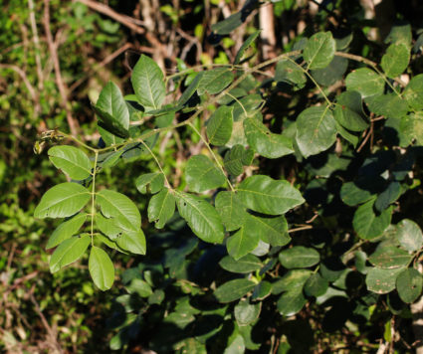](https://nurserylive.com/collections/medicinal-plants)](https://nurserylive.com/collections/medicinal-plants)

**88. Japanese hawkweed**

**Scientific name:** Youngia japonica

The plant is antitussive and febrifuge. It is also used in the treatment of boils and snakebites.

[[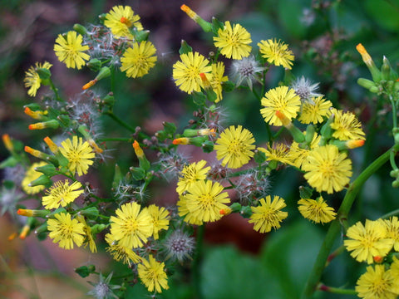](https://nurserylive.com/collections/medicinal-plants)](https://nurserylive.com/collections/medicinal-plants)

**89.**[**Jasmine**](https://nurserylive.com/collections/all/products/kunda-downy-jasmine-plant)

**Scientific name:** Jasminum officinale

It is used in dermatology as either an antiseptic or anti-inflammatory agent.

[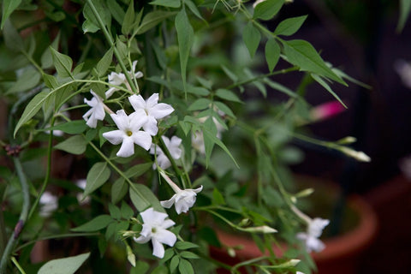](https://nurserylive.com/collections/all/products/kunda-downy-jasmine-plant)

**90. Kanna**

**Scientific name:** Sceletium tortuosum

African treatment for depression. Suggested to be an SSRI or have similar effects, but unknown mechanism of activity.

[[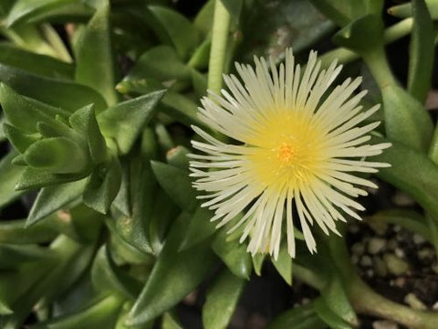](https://nurserylive.com/collections/medicinal-plants)](https://nurserylive.com/collections/medicinal-plants)

**91. Karvy**

**Scientific name:** Strobilanthes callosus

The plant is anti-inflammatory, antimicrobial, and anti-rheumatic.

[[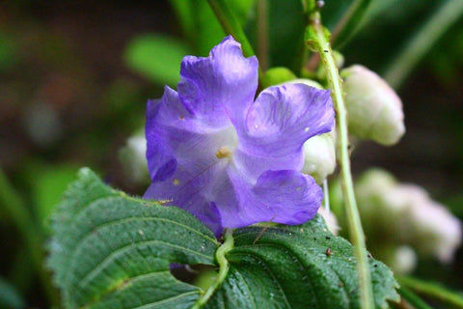](https://nurserylive.com/collections/medicinal-plants)](https://nurserylive.com/collections/medicinal-plants)

**92. Kava**

**Scientific name:** Piper methysticum

The plant has been used for centuries in the South Pacific to make a ceremonial drink with sedative and anesthetic properties. It is used as a soporific, as well as for asthma and urinary tract infection

[[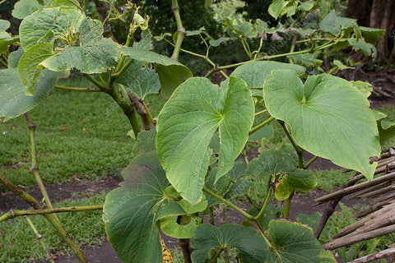](https://nurserylive.com/collections/medicinal-plants)](https://nurserylive.com/collections/medicinal-plants)

**93. Khat**

**Scientific name:** Catha edulis

Mild stimulant used for thousands of years in Yemen, and is banned today in many countries. Contains the amphetamine-like substance cathinone.

[[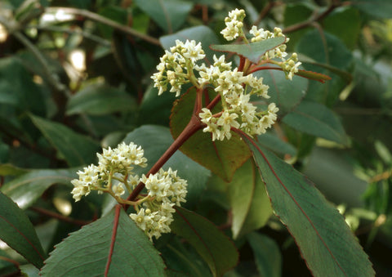](https://nurserylive.com/collections/medicinal-plants)](https://nurserylive.com/collections/medicinal-plants)

**94. Konjac**

**Scientific name:** Amorphophallus konjac

Significant dietary source of glucomannan, which is used in treating obesity, constipation, and reducing cholesterol.

[[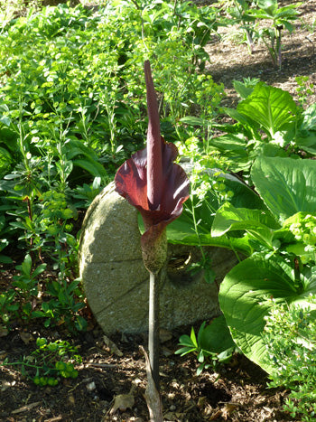](https://nurserylive.com/collections/medicinal-plants)](https://nurserylive.com/collections/medicinal-plants)

**95. Kratom**

**Scientific name:** Mitragyna speciosa

Kratom is known to prevent or delay withdrawal symptoms in an opioid-dependent individual, and it is often used to mitigate cravings thereafter. It can also be used for other medicinal purposes. Kratom has been traditionally used in regions such as Malaysia, Thailand, and Indonesia.

[[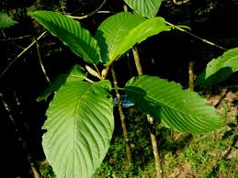](https://nurserylive.com/collections/medicinal-plants)](https://nurserylive.com/collections/medicinal-plants)

**96. Laurustinus**

**Scientific name:** Viburnum tinus

V. tinus has medicinal properties. The active ingredients are viburnin (a substance or more probably a mixture of compounds) and tannins. Tannins can cause stomach upset. The leaves when infused have antipyretic properties. The fruits have been used as purgatives against constipation. The tincture has been used lately in herbal medicine as a remedy for depression. The plant also contains iridoid glucosides.

[[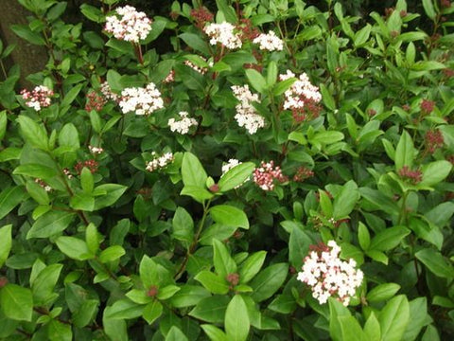](https://nurserylive.com/collections/medicinal-plants)](https://nurserylive.com/collections/medicinal-plants)

**97.**[**Lavender**](https://nurserylive.com/products/omx-lavender-seeds)

**Scientific name:** Lavandula angustifolia

It was traditionally used as an antiseptic and for mental health purposes. It was also used in ancient Egypt in mummifying bodies. There is little scientific evidence that lavender is effective for most mental health uses.

[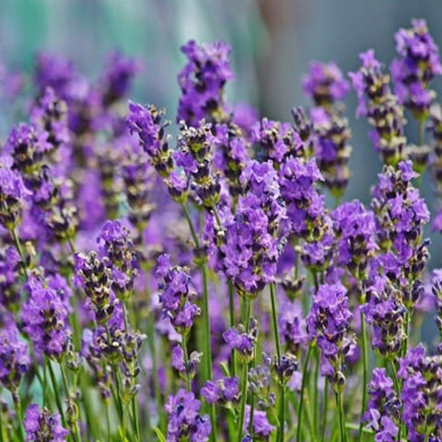](https://nurserylive.com/products/omx-lavender-seeds)

**98. Lemon**

**Scientific name:** Citrus limon

Along with other citruses, it has a long history of use in Chinese and Indian traditional medicine. In contemporary use, honey and lemon is common for treating coughs and sore throat.

[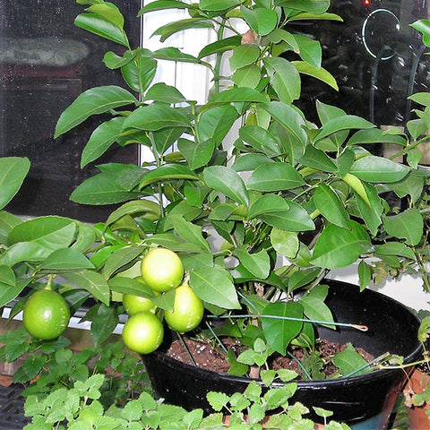](https://nurserylive.com/collections/medicinal-plants-type-fruit-plants-grafted)

**99.**[**Lemon balm**](https://nurserylive.com/collections/all/products/lemonn-grass-plant)

**Scientific name:** Melissa officinalis

It is used as a sleep aid and digestive aid.

[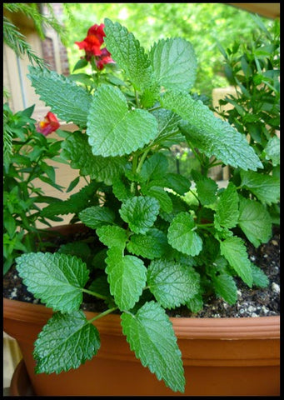](https://nurserylive.com/collections/all/products/lemonn-grass-plant)

**100. Licorice root**

**Scientific name:** Glycyrrhiza glabra

It has a long history of medicinal usage in Eastern and Western medicine. Uses include stomach ulcers, bronchitis, and sore throat, as well as infections caused by viruses, such as hepatitis.

[[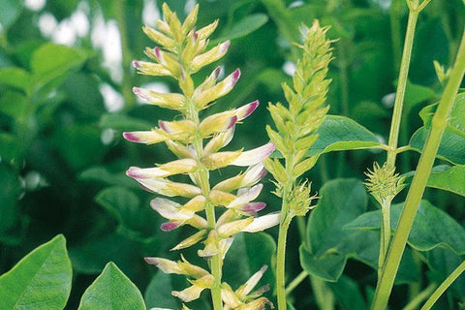](https://nurserylive.com/collections/medicinal-plants)](https://nurserylive.com/collections/medicinal-plants)

**101.**[**Lotus**](https://nurserylive.com/collections/all/products/lotus-nelumbo-nucifera-pink-plant)

**Scientific name:** Nelumbo nucifera

Sacred lotus has been the subject of a number of in-vitro and animal studies, exploring its pharmacologic effects, including antioxidant, hepatoprotective, immunomodulatory, anti-infective, hyperlipidemic, and psychopharmacologic activity although clinical trials are lacking.

[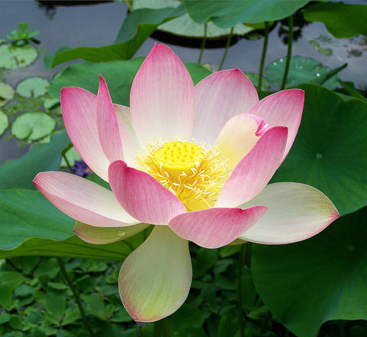](https://nurserylive.com/collections/all/products/lotus-nelumbo-nucifera-pink-plant)

**102. Magnolia-bark**

**Scientific name:** Magnolia officinalis

The bark contains magnolol and honokiol, two polyphenolic compounds. Preclinical studies have evaluated their various potential applications including antioxidant, anti-inflammatory, antitumor, and antimicrobial properties.

[[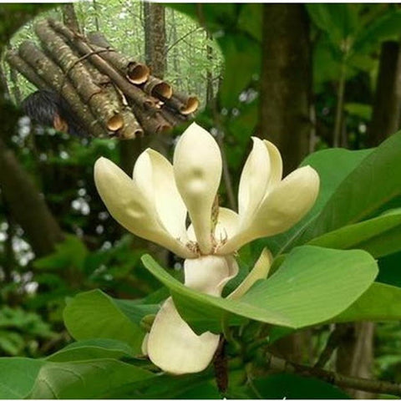](https://nurserylive.com/collections/medicinal-plants)](https://nurserylive.com/collections/medicinal-plants)

**103.**[**Mallow**](https://nurserylive.com/products/country-mallow-plant)

**Scientific name:** Malva sylvestris

The seeds are used internally in a decoction or herbal tea as a demulcent and diuretic, and the leaves made into poultices as an emollient for external applications.

[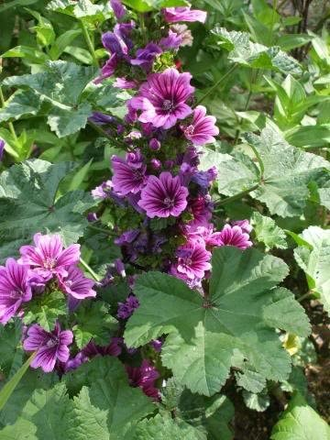](https://nurserylive.com/products/country-mallow-plant)

**104.**[**Marigold**](https://nurserylive.com/collections/all/products/mexican-marigold-plant)

**Scientific name:** Calendula officinalis

Also named calendula, has a long history of use in treating wounds and soothing skin

[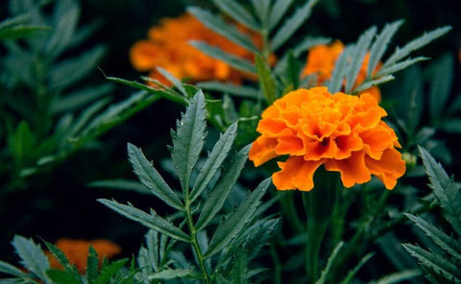](https://nurserylive.com/collections/all/products/mexican-marigold-plant)

**105. Marsh-mallow**

**Scientific name:** Althaea officinalis

Used for over 2,000 years as both a food and a medicine

[[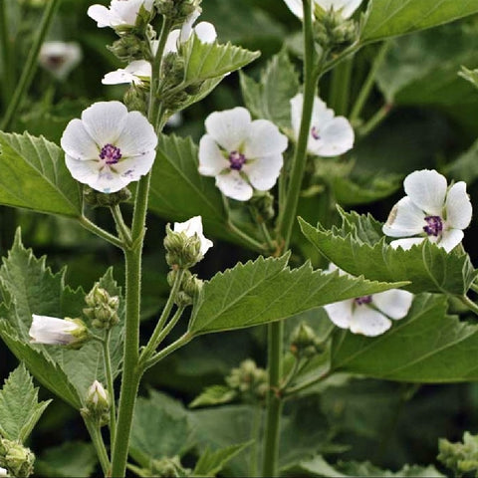](https://nurserylive.com/collections/medicinal-plants)](https://nurserylive.com/collections/medicinal-plants)

**106. Milk thistle**

**Scientific name:** Silybum marianum

It has been used for thousands of years for a variety of medicinal purposes, in particular liver problems.

[[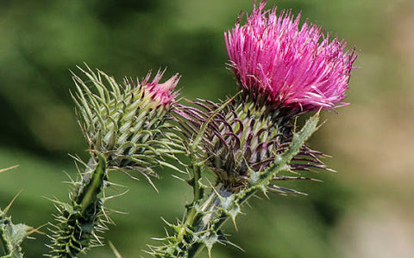](https://nurserylive.com/collections/medicinal-plants)](https://nurserylive.com/collections/medicinal-plants)

**107. Minnieroot, fever root, snapdragon root**

**Scientific name:** Ruellia tuberosa

In folk medicine and Ayurvedic medicine it has been used as a diuretic, anti-diabetic, antipyretic, analgesic, antihypertensive,  gastroprotective, and to treat gonorrhea.

[[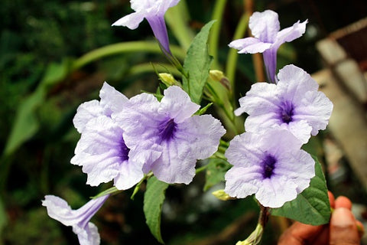](https://nurserylive.com/collections/medicinal-plants)](https://nurserylive.com/collections/medicinal-plants)

**108. Xanthoparmelia scabrosa**

**Scientific name:** Xanthoparmelia scabrosa

It is a lichen used for sexual dysfunction.

[[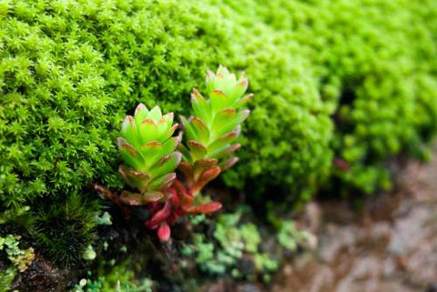](https://nurserylive.com/collections/medicinal-plants)](https://nurserylive.com/collections/medicinal-plants)

**109.**[**Neem**](https://nurserylive.com/collections/all/products/tree-of-andhra-pradesh-neem-plant)

**Scientific name:** Azadirachta indica

Used in India to treat worms, malaria, rheumatism and skin infections among many other things. Its many uses have led to neem being called "the village dispensary" in India.

[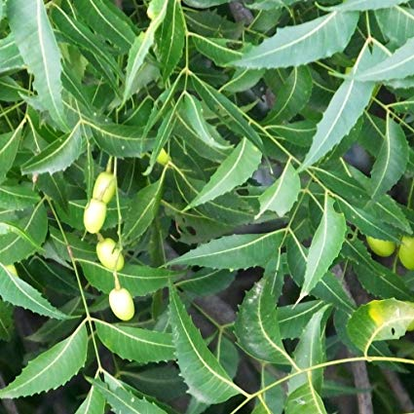](https://nurserylive.com/collections/all/products/tree-of-andhra-pradesh-neem-plant)

**110. Nigella, black-caraway, black-cumin, and kalonji**

**Scientific name:** Nigella sativa

It has efficacy as a therapy, mainly using the seed oil extract, volatile oil, and isolated constituent thymoquinone. One meta-analysis of clinical trials concluded that N. sativa has a short-term benefit on lowering systolic and diastolic blood pressure.

[[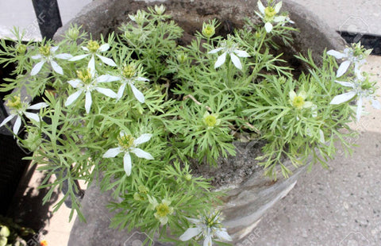](https://nurserylive.com/collections/medicinal-plants)](https://nurserylive.com/collections/medicinal-plants)

**111.**[**Noni**](https://nurserylive.com/collections/all/products/cheese-fruit-noni-plant)

**Scientific name:** Morinda citrifolia

It has a history of use as for joint pain and skin conditions.

[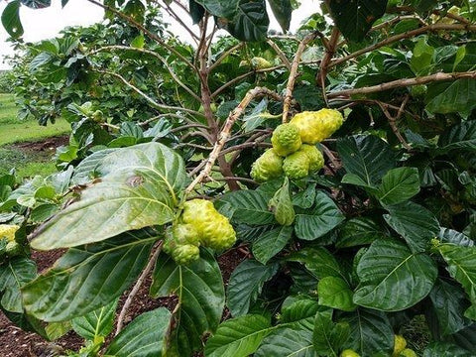](https://nurserylive.com/collections/all/products/cheese-fruit-noni-plant)

**112. Opium poppy**

**Scientific name:** Papaver somniferum

The plant is the plant source of morphine, used for pain relief. Morphine made from the refined and modified sap is used for pain control in terminally ill patients. Dried sap was used as a traditional medicine until the 19th century.[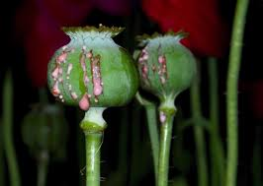](https://nurserylive.com/collections/medicinal-plants)

113. [Oregano](https://nurserylive.com/products/oregano-plant)

**Scientific name:** Origanum vulgare

Used as an abortifacient in folk medicine in some parts of Bolivia and other northwestern South American countries, though no evidence of efficacy exists in Western medicine. Hippocrates used oregano as an antiseptic, as well as a cure for stomach and respiratory ailments. A Cretan oregano (O. dictamnus) is still used today in Greece as a palliative for sore throat. Evidence of efficacy in this matter is lacking.

[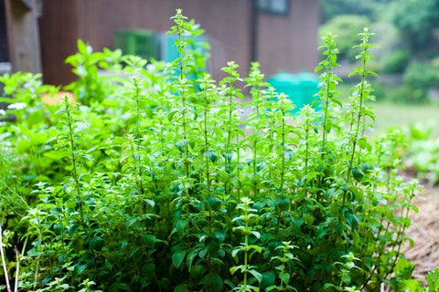](https://nurserylive.com/products/oregano-plant)

**114.**[**Papaya**](https://nurserylive.com/products/papaya-papita-hybrid-plant)

**Scientific name:** Carica papaya

Used for treating wounds and stomach troubles.

[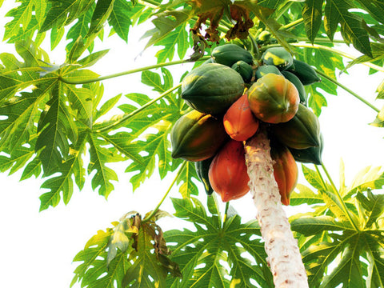](https://nurserylive.com/products/papaya-papita-hybrid-plant)

**115.**[**Passion flower**](https://nurserylive.com/products/krishna-kamal-passion-flower-passiflora-incarnata-purple-plant)

**Scientific name:** Passiflora

Thought to have anti-depressant properties. Unknown MOA. Used in traditional medicine to aid with sleep or depression.

[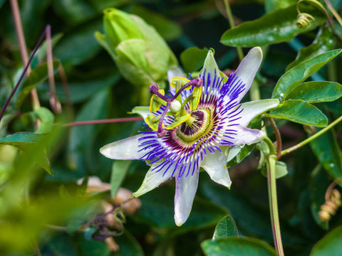](https://nurserylive.com/products/krishna-kamal-passion-flower-passiflora-incarnata-purple-plant)

**116.**[**Peppermint**](https://nurserylive.com/collections/all/products/mentha-piperita-peppermint-plant)

**Scientific name:** Mentha x piperita

Its oil, from a cross between water mint and spearmint, has a history of medicinal use for a variety of conditions, including nausea, indigestion, and symptoms of the common cold.

[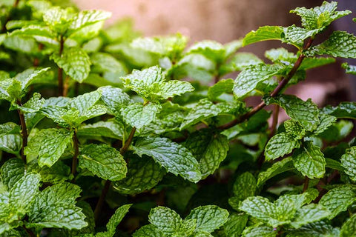](https://nurserylive.com/collections/all/products/mentha-piperita-peppermint-plant)

**117. Plantain**

**Scientific name:** Plantago lanceolata

It is used frequently in herbal teas and other herbal remedies. A tea from the leaves is used as a highly effective cough medicine. In the traditional Austrian medicine Plantago lanceolata leaves have been used internally (as syrup or tea) or externally (fresh leaves) for treatment of disorders of the respiratory tract, skin, insect bites, and infections.

[[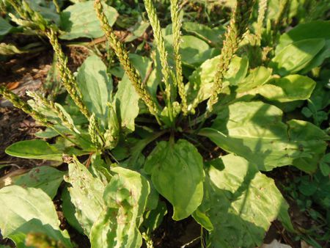](https://nurserylive.com/collections/medicinal-plants)](https://nurserylive.com/collections/medicinal-plants)

**118. Platycodon, balloon flower**

**Scientific name:** Platycodon grandiflorus

The extracts and purified platycoside compounds (saponins) from the roots may exhibit neuroprotective, antimicrobial, anti-inflammatory, anti-cancer, anti-allergy, improved insulin resistance, and cholesterol-lowering properties.

[[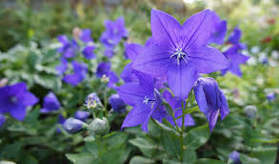](https://nurserylive.com/collections/medicinal-plants)](https://nurserylive.com/collections/medicinal-plants)

**119. Purple coneflower**

**Scientific name:** Echinacea purpurea

This plant and other species of Echinacea have been used for at least 400 years by Native Americans to treat infections and wounds, and as a general "cure-all" (panacea). It is currently used for symptoms associated with cold and flu

[[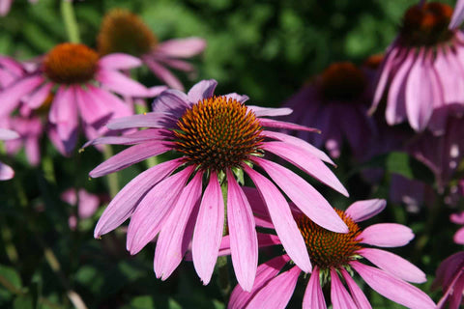](https://nurserylive.com/collections/medicinal-plants)](https://nurserylive.com/collections/medicinal-plants)

**120. Red clover**

**Scientific name:** Trifolium pratense

The plant is an ingredient in some recipes for essiac tea. Research has found no benefit for any human health conditions.

[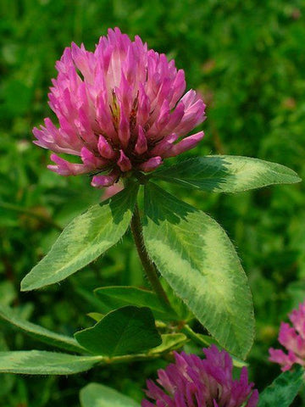](https://nurserylive.com/collections/medicinal-plants)

**121. Robert geranium**

**Scientific name:** Geranium robertianum

In traditional herbalism, it was used as a remedy for toothache and nosebleeds and as a vulnerary (used for or useful in healing wounds).

[[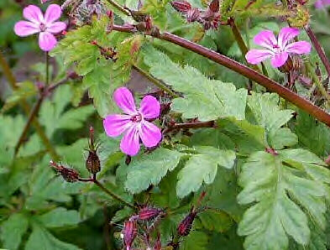](https://nurserylive.com/collections/medicinal-plants)](https://nurserylive.com/collections/medicinal-plants)

**122.**[**Rosemary**](https://nurserylive.com/collections/all/products/omx-rosemary-seeds)

**Scientific name:** Rosmarinus officinalis

It has been used medicinally from ancient times.

[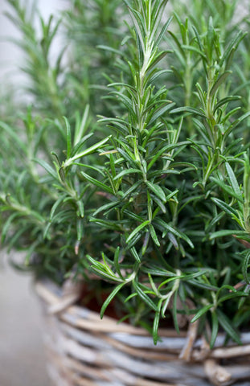](https://nurserylive.com/collections/all/products/omx-rosemary-seeds)

**123.**[**Sage**](https://nurserylive.com/collections/all/products/clary-sage-plant)

**Scientific name:** Salvia officinalis

Shown to improve cognitive function in patients with mild to moderate Alzheimer's disease

[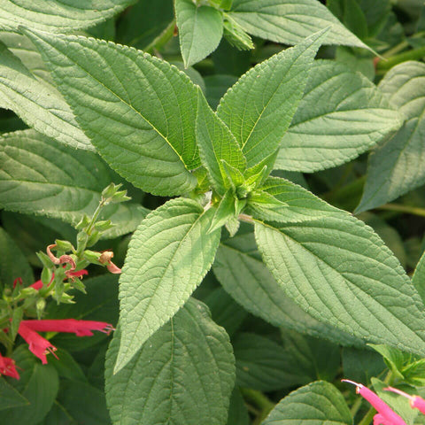](https://nurserylive.com/collections/all/products/clary-sage-plant)

**124. Salae**

**Scientific name:** Broussonetia kurzii

Known as Salae in Thailand where this species is valued as a medicinal plant.

[[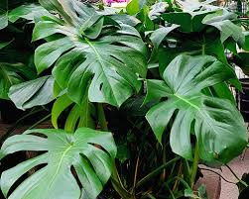](https://nurserylive.com/collections/medicinal-plants)](https://nurserylive.com/collections/medicinal-plants)

**125. Sao Caetano melon**

**Scientific name:** Cayaponia espelina

It is a diuretic and aid in the treatment of diarrhea and syphilis.

[[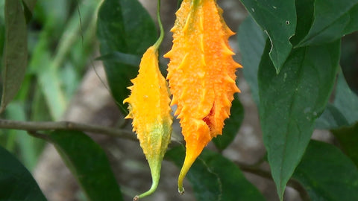](https://nurserylive.com/collections/medicinal-plants)](https://nurserylive.com/collections/medicinal-plants)

**126. Sea buckthorn**

**Scientific name:** Hippophae rhamnoides

The leaves are used as herbal medicine to alleviate cough and fever, pain, and general gastrointestinal disorders as well as to cure dermatologic disorders. Similarly, the fruit juice and oils can be used in the treatment of liver disease, gastrointestinal disorders, chronic wounds or other dermatological disorders.

[[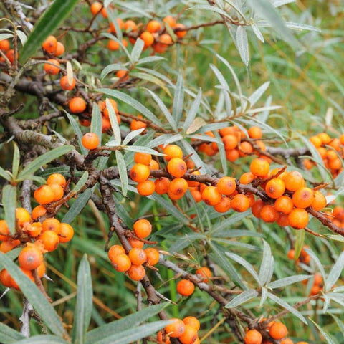](https://nurserylive.com/collections/medicinal-plants)](https://nurserylive.com/collections/medicinal-plants)

**127. Shoreline purslane**

**Scientific name:** Sesuvium portulacastrum

The plant extract showed antibacterial and anticandidal activities and moderate antifungal activity.

[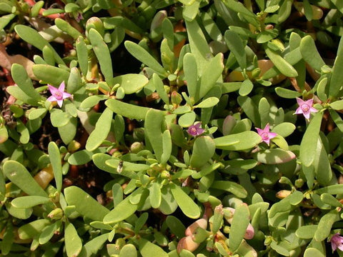](https://nurserylive.com/collections/medicinal-plants)

**128. Small-leaved linden**

**Scientific name:** Tilia cordata

In the countries of Central, Southern and Western Europe, linden flowers are a traditional herbal remedy made into an herbal tea called tisane.

[[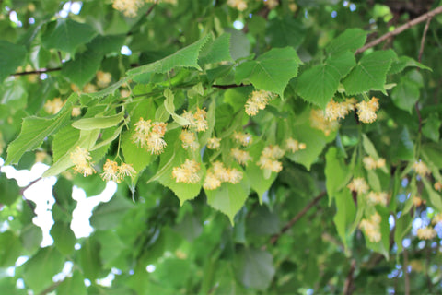](https://nurserylive.com/collections/medicinal-plants)](https://nurserylive.com/collections/medicinal-plants)

**129. Snowdrop**

**Scientific name:** Galanthus

It contains an active substance called galantamine, which is an acetylcholinesterase inhibitor. Galantamine (or galanthamine) can be helpful in the treatment of Alzheimer's disease, though it is not a cure.

[[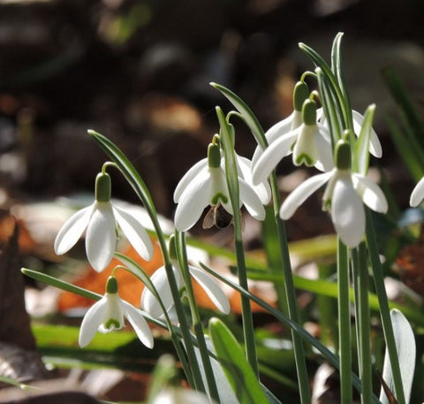](https://nurserylive.com/collections/medicinal-plants)](https://nurserylive.com/collections/medicinal-plants)

**130. St. John's wort**

**Scientific name:** Hypericum perforatum

Widely used within herbalism for depression. Evaluated for use as an antidepressant, but with ambiguous results.

[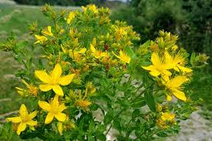](https://nurserylive.com/collections/medicinal-plants)

**131. Star anise**

**Scientific name:** Illicium verum

It is the major source of the chemical compound shikimic acid, a primary precursor in the pharmaceutical synthesis of anti-influenza drug oseltamivir (Tamiflu).

**132. Summer savory**

**Scientific name:** Satureja hortensis

Its extracts show antibacterial and antifungal effects on several species including some of the antibiotic resistant strains.

[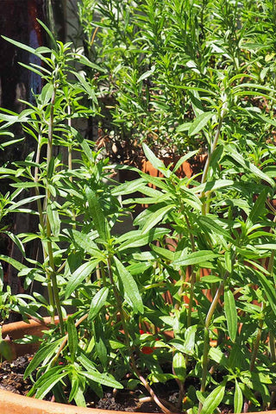](https://nurserylive.com/collections/gardening)

**133. Summer snowflake**

**Scientific name:** Leucojum aestivum

It is known to contain Galantamine (Nivalin, Razadyne, Razadyne ER, Reminyl, Lycoremine in pharmaceutical format). It is used for the treatment of mild to moderate Alzheimer's disease and various other memory impairments, in particular those of vascular origin.

[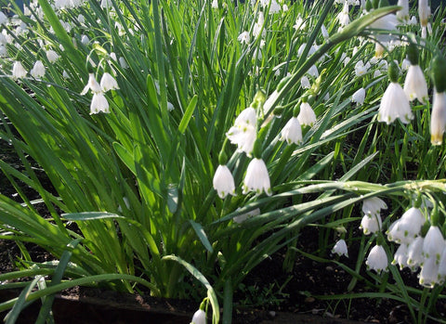](https://nurserylive.com/collections/gardening)

**134. Syrian Rue (aka Harmal)**

**Scientific name:** Peganum harmala

Can be used as an antidepressant, but carries significant risk. Used in traditional shamanistic rites in the amazon, and is a component of Ayahuasca, Caapi or Yajé (which is actually usually Banisteriopsis caapi but has the same active alkaloids).

**135. Tea tree oil**

**Scientific name:** Melaleuca alternifolia

It has been used medicinally for centuries by Australian aboriginal people. Modern usage is primarily as an antibacterial or antifungal agent.

[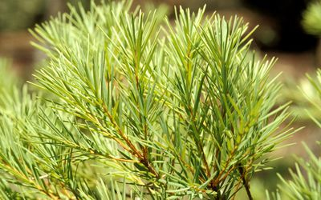](https://nurserylive.com/collections/gardening)

**136.**[**Thyme**](https://nurserylive.com/collections/all/products/thyme-thymus-vulgaris-plant)

**Scientific name:** Thymus vulgaris

The plant is used to treat bronchitis and cough. It serves as an antispasmodic and expectorant in this role. It has also been used in many other medicinal roles in Asian and Ayurvedic medicine, although it has not been shown to be effective in non-respiratory medicinal roles.

[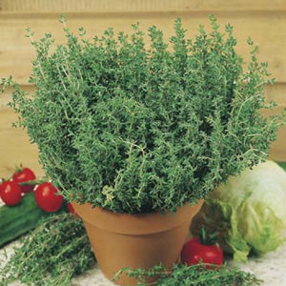](https://nurserylive.com/collections/all/products/thyme-thymus-vulgaris-plant)

**137. Trifoliate orange, bitter orange**

**Scientific name:** Citrus trifoliata

Fruits of Citrus trifoliata are widely used in Oriental medicine as a treatment for allergic inflammation.

[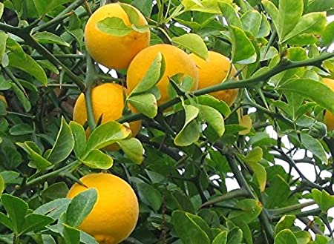](https://nurserylive.com/collections/gardening)

**138. [Tulsi or holy basil](https://nurserylive.com/collections/all/products/krishna-tulsi-tulsi-black-seeds" \o "Tulsi" \t "_blank)**

**Scientific name:** Ocimum tenuiflorum

It is used for a variety of purposes in traditional medicine; tulsi is taken in many forms: as herbal tea, dried powder, fresh leaf or mixed with ghee. Essential oil extracted from Karpoora tulasi is mostly used for medicinal purposes and in herbal cosmetics.

[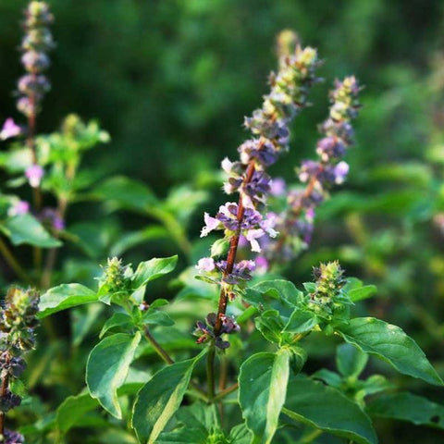](https://nurserylive.com/collections/all/products/krishna-tulsi-tulsi-black-seeds)

**139.**[**Turmeric**](https://nurserylive.com/collections/all/products/black-turmeric-plant-black-haldi-plant)

**Scientific name:** Curcuma longa

Spice that lends its distinctive yellow color to Indian curries, has long been used in Ayurvedic and traditional Chinese medicine to aid digestion and liver function, relieve arthritis pain, and regulate menstruation.

[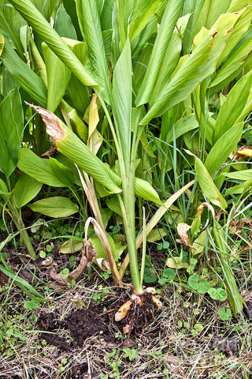](https://nurserylive.com/collections/all/products/black-turmeric-plant-black-haldi-plant)

**140. Umckaloabo, or South African Geranium**

**Scientific name:** Pelargonium sidoides

It is used in treating acute bronchitis

**141 Valerian**

**Scientific name:** Valeriana officinalis

It has been used since at least ancient Greece and Rome for sleep disorders and anxiety.

**142. Velvetleaf**

**Scientific name:** Cissampelos pareira

Used for a wide variety of conditions.

[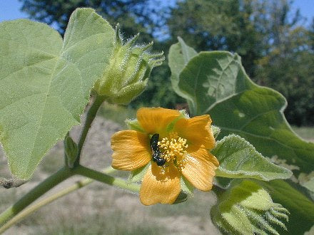](https://nurserylive.com/collections/gardening)

**143.**[**Verbena**](https://nurserylive.com/products/verbena-plant)

**Scientific name:** Verbena officinalis

It is used for sore throats and respiratory tract diseases.

[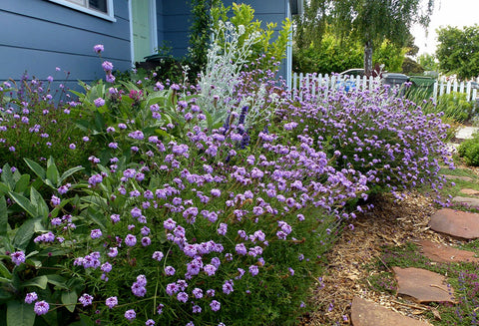](https://nurserylive.com/products/verbena-plant)

**144. Veronica**

**Scientific name:** Veronica officinalis

The plant is used for sinus and ear infections.

[[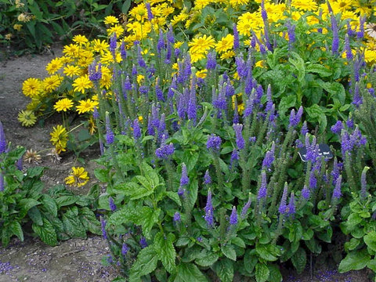](https://nurserylive.com/collections/medicinal-plants)](https://nurserylive.com/collections/medicinal-plants)

**145.**[**Vetiver**](https://nurserylive.com/collections/all/products/khus-vetiver-plant)

**Scientific name:** Chrysopogon zizanioides

Used for skin care.

[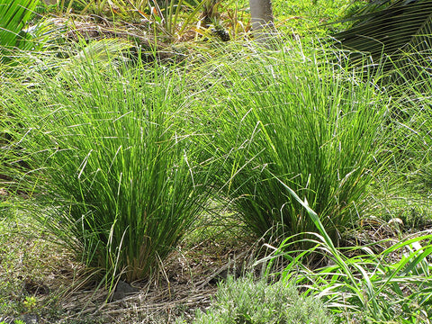](https://nurserylive.com/collections/all/products/khus-vetiver-plant)

**146. Wafer Ash**

**Scientific name:** Ptelea trifoliata

The root bark is used for the digestive system. Also known as hoptree.

[[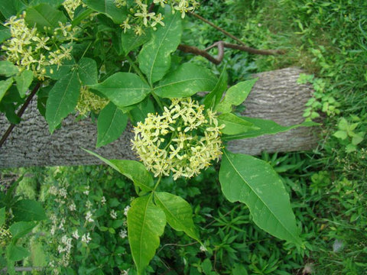](https://nurserylive.com/collections/medicinal-plants)](https://nurserylive.com/collections/medicinal-plants)

**147. Wahoo**

**Scientific name:** Euonymus atropurpureus

Plant is a purgative and might affect the heart.

[[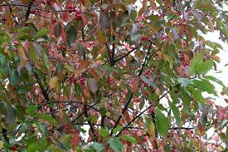](https://nurserylive.com/collections/medicinal-plants)](https://nurserylive.com/collections/medicinal-plants)

**148. Water germander**

**Scientific name:** Teucrium scordium

It has been used for asthma, diarrhea, fever, intestinal parasites, hemorrhoids, and wounds.

[[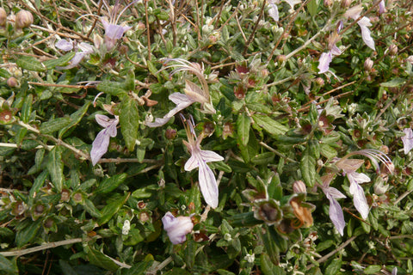](https://nurserylive.com/collections/medicinal-plants)](https://nurserylive.com/collections/medicinal-plants)

**149. Water-plantain**

**Scientific name:** Alisma plantago-aquatica

Used for the urinary tract.

**150.**[**Watercress**](https://nurserylive.com/collections/all/products/watercress-plant)

**Scientific name:** Nasturtium officinale

It may be diuretic and antibacterial.

[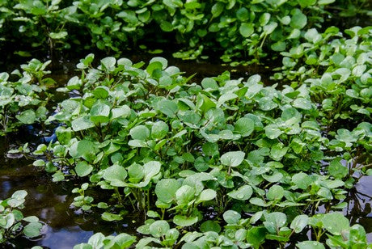](https://nurserylive.com/collections/all/products/watercress-plant)

**151. Wheatgrass**

**Scientific name:** Triticum aestivum

It may contain antioxidant and anti-inflammatory compounds.

[[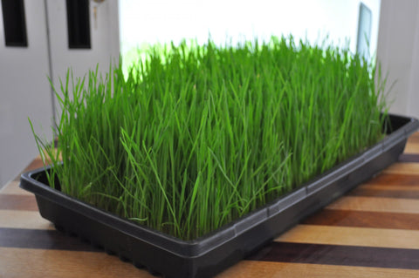](https://nurserylive.com/collections/medicinal-plants)](https://nurserylive.com/collections/medicinal-plants)

**152. White buttercup**

**Scientific name:** Turnera subulata

It is used for skin, gastrointestinal, and respiratory ailments. Laboratory tests showed it has some inhibitory activity against various fungi, such as Candida glabrata, Aspergillus flavus, A. niger, A. fumigatus, Penicillium chrysogenum, and Candida albicans.

[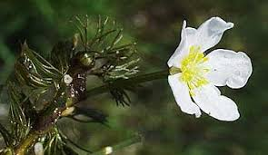](https://nurserylive.com/collections/gardening)

**153. White snakeroot**

**Scientific name:** Ageratina altissima

Root tea has been used to treat diarrhea, kidney stones, and fever. A root poultice can be used on snakebites.

[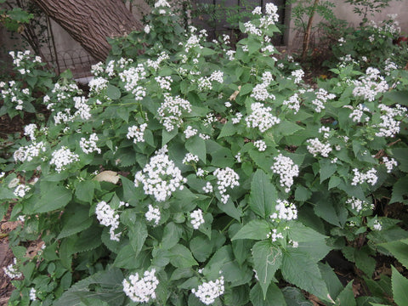](https://nurserylive.com/collections/medicinal-plants)

**154. White willow**

**Scientific name:** Salix alba

Plant source of salicylic acid, white willow is like the chemical known as aspirin, although more likely to cause stomach upset as a side effect than aspirin itself which can cause the lining in your stomach to be destroyed. Used from ancient times for the same uses as aspirin.

[[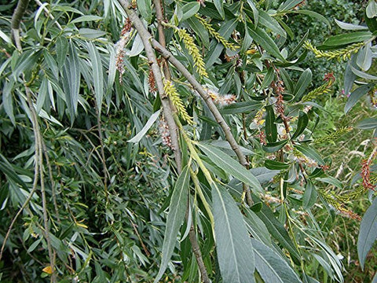](https://nurserylive.com/collections/medicinal-plants)](https://nurserylive.com/collections/medicinal-plants)

**155. Wild pansy**

**Scientific name:** Viola tricolor

It is one of many viola plant species containing cyclotides. These small peptides have proven to be useful in drug development due to their size and structure giving rise to high stability. Many cyclotides, found in Viola tricolor are cytotoxic. This feature means that it could be used to treat cancers.

[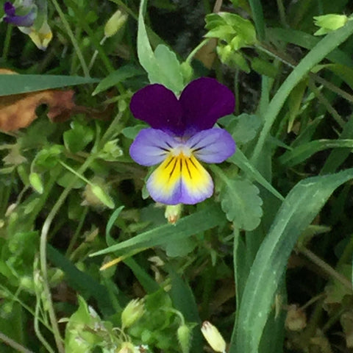](https://nurserylive.com/collections/medicinal-plants)

**156. Yellow lady's slipper**

**Scientific name:** Cypripedium parviflorum

The Cypripedium species have been used in native remedies for dermatitis, tooth aches, anxiety, headaches, as an antispasmodic, stimulant and sedative. However, the preferred species for use are Cyp. parviflorum and Cyp.acaule, used as topical applications or tea.

[[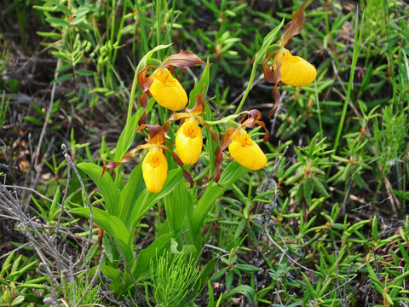](https://nurserylive.com/collections/medicinal-plants)](https://nurserylive.com/collections/medicinal-plants)

**157. Yerba mate**

**Scientific name:** Ilex paraguariensis

It has been claimed to have various effects on human health and these effects have been attributed to the high quantity of polyphenols found in mate tea. Mate contains compounds that act as an appetite suppressant, increases mental energy and focus, and improves mood. Yerba mate also contains elements such as potassium, magnesium, and manganese.

[[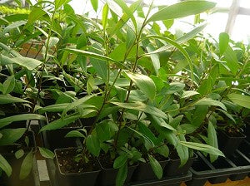](https://nurserylive.com/collections/medicinal-plants)](https://nurserylive.com/collections/medicinal-plants)

**158. Yerba Santa**

**Scientific name:** Eriodictyon crassifolium

Used by the Chumash people to keep airways open for proper breathing.

[[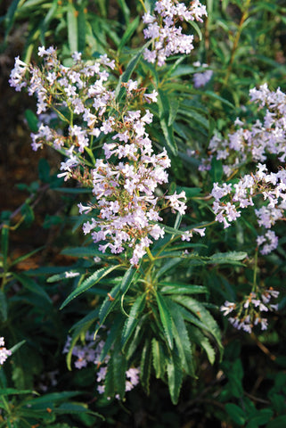](https://nurserylive.com/collections/medicinal-plants)](https://nurserylive.com/collections/medicinal-plants)

**Conservation of plants medicine**

The propagation of plant medicine has been a fundamental operation of mankind. When new kinds of plants have to be conserved or propagated, we need to develop knowledge and techniques to propagate them.

An appropriate propagation technology can be selected for each kind of plants medicine depending upon plant growth

Traditional plants medicine is still recognized as the preferred primary health care system in many communities, with over 60% of the world’s population and about 80% in developing countries depending directly on medicinal plants for their medical purposes.

This is due to a number of reasons including affordability, accessibility, and low cost.